Offset Inboard Electric Drive
OPERATORS MANUAL

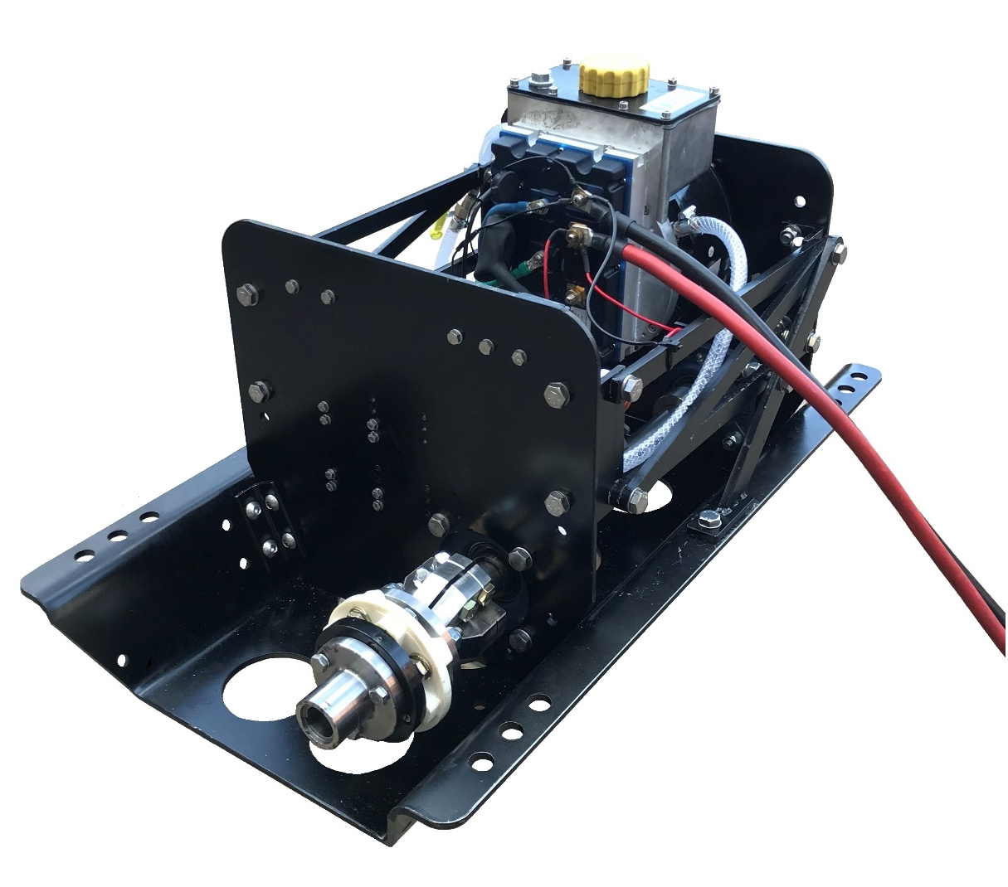

For the following models*:
6.5kW

*Standard model, there may be optional extras or alternative components fitted that are not shown within this manual.
SAFETY

Barrus is concerned for your safety. We use safety statements throughout the manual to call your attention to the potential hazards associated with the operation of your electric propulsion inboard.

Follow the precautions listed throughout the manual before operation, during operation and during servicing/maintenance procedures for your safety, the safety of others and to protect the performance of your motor.

Safety alert symbols appear throughout the manual. It means attention, be alert as your safety is involved. Please read and follow the message that appears after the safety alert symbol.

 |  | NOTICE: | This indicates a situation which can cause damage to the machine, personal property and/or the environment or cause the equipment to operate improperly
 |  | CAUTION: | This indicates a hazardous situation which, if not avoided, could result in minor or moderate injury.
 | WARNING: |  | This indicates a hazardous situation which, if not avoided, could result in death or serious injury.
 | DANGER: |  | This indicates a hazardous situation which, if not avoided, will result in death or serious injury.

Motor Details

Motor Model Number:

Motor Serial Number:

Please enter your motor model number and serial number in the space provided above. Please quote the motor identification number during any enquiry or when ordering spare parts. Information about the motor serial number and its location on the cover can be found in SECTION 2 of the manual.

This manual is for the following models:
- Shire 6.5kW (10hp) Offset Inboard Electric Drive

Description
Water cooled offset electric inboard drive using a 3-phase permanent magnet BLDC, 48v electric motor. The inboard includes a remote shifter with three speed modes. Bluetooth performance monitoring system is used to indicate main parameters.

Motor specifications, Benefits and Optional extras
Specifications:
- 48 Volt electric inboard
- Water cooled brushless, permanent magnet electric motor
- Inboard remote shifter
- Anti-vibration mount
- Flexible output shaft coupling
- Safety lanyard
Benefits:
- Variable speed ranges. Can be locked for commercial and hire boat situations
- Motor overload cut out
- Spare parts readily available
Optional extras:
- Optional right hand shifter
- Other options not listed here are available

Operators Manual

NOTICE:
THIS MANUAL FORMS AN INTEGRAL PART OF THE INBOARD IT ACCOMPANIES, IF A TRANSFER OF TITLE OCCURS, IT MUST ALWAYS BE HANDED OVER TO THE NEW OWNER.

Thank you for purchasing this electric inboard drive from Barrus. This manual has been compiled to help you to operate your inboard and its associated parts with safety and pleasure. Please read it and familiarise yourself with the inboard and its parts before operation.

The information and recommendations given in this manual are based on the latest information available at the time of publication. Barrus reserve the right to change the specification of its products and manuals without prior notice.

Depending upon the equipment specification of the inboard and accessories fitted, there may be discrepancies or differences with the information presented in this handbook. No claims may be pursued in this respect.

Ensure that you read and understand the contents of the manual before attempting to operate the unit.

Disclaimer: All product, product specifications and data are subject to change without notice to improve reliability, function, design or otherwise. All product information is correct at the time of issue.

WARRANTY

This Limited Warranty provides coverage for one (1) year or 500 hours (whichever occurs first) for all commercial applications and two (2) years for leisure customers. This is for mechanical parts and electrical parts from the date of warranty registration. The warranty is for non-serviceable items. The repair or replacement of parts, or the performance of service under this warranty, does not extend the life of this warranty beyond its original expiry date.

To ensure that you have been registered for your warranty, please detach and fill in the form on the back of this manual. Return it to the address given or email to Richard.Cooke@barrus.co.uk
The Warranty will only apply if the following have been carried out and the registration form has been completed and returned to Barrus.

CONDITIONS THAT MUST BE MET IN ORDER TO OBTAIN WARRANTY COVERAGE
Warranty coverage is only available from Barrus or an authorised dealer in the country in which the sale occurred. Routine maintenance outlined in the Owner’s Manual must be performed using genuine parts in order to maintain warranty coverage. If the customer does not carry out normal maintenance or makes unauthorised alterations or modifications the warranty coverage will become void, Barrus reserves the right to make future warranty coverage possible only with proof of proper maintenance.

WARRANTY CLAIMS
Warranty claims shall be made directly to Barrus or by an authorised dealer.
The dealer will then arrange for the inspection and any necessary repairs. If the repairs carried out are not covered by the warranty, the purchaser shall pay for all related labour and material, and any other expenses associated with that service.

WHAT IS NOT COVERED
This limited warranty does not cover routine maintenance items, adjustments, normal wear and tear, damage caused by abnormal use, operation of the product in a manner inconsistent with the recommended operation/duty cycle section of the Owner’s Manual, accident, submersion, improper installation (proper installation specification and techniques are set forth in the Operations and First time running sections in this manual), use of an accessory or part not manufactured or sold by us, or alteration or removal of parts. Expenses related to crane-out, launch, towing, storage, telephone, rental, inconvenience, slip fees, insurance coverage, loan payments, loss of time, loss of income, or any other types of accidental or consequential damages are not covered by this warranty.
Damage due to rust or corrosion, submersion, or unreasonable exposure to the environment, such as exposure to high humidity, rain fall, or seawater, or conditions resulting in the freezing of cooling water are also not covered.

Index
Page
SECTION 1 – Safety Precautions 10
1. General 10
2. Lifting 10
3. Rotating Parts 10
4. Propeller 11
5. Electrics 11
6. Batteries 11
7. Safety Lanyard 12
8. Motor Overload 13
9. Modifications 13
10. Boat 13
11. Passenger Training 13
12. Terminal Crimping 14
13. Applicable Standards 14
SECTION 2 – Identification 15
SECTION 3 – Component Identification 16
1. 6.5kW Offset Electric Drive (Front) 16
2. 6.5kW Offset Electric Drive (Rear) 16
3. Speed and Direction Control Lever 17
SECTION 4 – Installation 18
1. Unpacking the Inboard Motor 18
2. Filling the Inboard Motor with Coolant 18
3. Battery Selection 20
4. Battery Type Selection 22
5. Anderson Type Connectors 22
6. Battery Installation 23
7. Battery Storage 24
8. Connecting Speed and Direction Control Lever 24
SECTION 5 – Operation 25
1. General 25
2. Starting Procedure (Speed and direction control lever) 26
3. Stopping Procedure (Speed and direction control lever) 27
4. Application Downloads and Information 27
SECTION 6 – Maintenance 31
1. General 31
SECTION 7 – Transportation and Storage 32
1. Transporting 32
2. Storage 32
SECTION 8 – Wiring Diagrams 33
1. Wiring Diagram for Offset Electric Drive 33
2. Wiring Diagram for Speed and Direction Control Lever 34
SECTION 9 – Technical Data 35
1. Inboard Data 35
2. Dry Weight of Unit Data 35
3. Inboard Dimensions 36
SECTION 10 – System Protection Characteristics 37
SECTION 11 – Spare Parts 38
SECTION 12 – Special Tools 40
SECTION 13 – Afterlife Recycling 41
SECTION 14 – Declarations 42
1. LiFEP04 Battery TUV Safety Data Sheet 42

SECTION 1 – Safety Precautions
- General

NOTICE:
NEVER PERMIT ANYONE TO OPERATE THE INBOARD WITHOUT PROPER TRAINING.

Ensure that the engine battery isolator switch is in the off position before connecting the battery, carrying out any maintenance or repairs. Also, when the inboard is not in use.
- Lifting

DANGER:
CRUSH HAZARD! NEVER STAND UNDER A HOISTED ENGINE. IF THE HOIST MECHANISM FAILS, THE ENGINE WILL FALL ON YOU, CAUSING SERIOUS INJURY OR DEATH.

- Note: Suitable safe lift equipment must be used to lift, move, and mount the inboard into the boat.
- The batteries used for the inboard will be heavy. Make sure safe lifting procedures or suitable cranes or hoists are used when moving and installing them.

- Rotating Parts

WARNING:
SEVERE HAZARD! KEEP HANDS AND OTHER BODY PARTS AWAY FROM MOVING/ROTATING PARTS. WEAR TIGHT FITTING CLOTHING AND KEEP YOUR HAIR SHORT OR TIE BACK. REMOVE ALL JEWELLERY BEFORE COMMENCING WORK. CHECK BEFORE STARTING THE INBOARD THAT ANY TOOLS OR RAGS USED DURING MAINTENANCE HAVE BEEN REMOVED FROM THE AREA.

The inboard and its accessories are not intended to be put into operation until they are integrated into the boat as a whole. The top cowl must always be fitted whilst the motor is running.
- Propeller

CAUTION

- The propeller has sharp edges which can cause injury even when it is stationary. If there is someone in the water near the motor, it must be switched off.
- If the propeller is damaged, it may become unbalanced and cause either bad vibrations or the inboard to fail. Do not use the inboard in this situation.

- Electrics

CAUTION

- Do not touch any electrical parts while operating the motor. The electrical parts may cause shock or electrocution.
- Ensure all electrical connections are insulated against accidental short circuit.
- Batteries

DANGER:
EXPLOSION HAZARD! NEVER SHORT OUT THE BATTERY TERMINALS, INCLUDING WHEN CHECKING THE REMAINING BATTERY CHARGE THIS WILL RESULT IN A SPARK AND MAY CAUSE AN EXPLOSION OR FIRE.

WARNING:
BURN HAZARD! BATTERIES CONTAIN SULPHURIC ACID. NEVER ALLOW BATTERY FLUID TO COME IN CONTACT WITH SKIN, EYES OR CLOTHING. SEVERE BURNS COULD RESULT. MAKE SURE THE CORRECT PERSONAL PROTECTION EQUIPMENT IS WORN.
- Batteries can produce explosive gases; keep sparks and flames away from the battery.
NO SMOKING
- Lead acid batteries contain sulphuric acid; if splashed on skin or eyes, flush well with water and seek medical advice.
- Keep battery tops and battery compartment ventilated at all times.
- If disconnecting the battery; remove the earth lead FIRST; and re-connect it last.
- If charging the battery; ensure that the charger is switched off before connecting and disconnecting.
- Do not tip the battery on its side.
- Please see label on battery or manufacturer’s instructions for specific information.
- A battery master (on/off) switch must be installed in the system.
- Safety Lanyard

WARNING:

- The magnetic safety lanyard tag should always be attached to the stop switch area on the remote shifter and to the person operating the boat before the motor is started. This will prevent the inboard from operating if the operator falls overboard or leaves the helm.

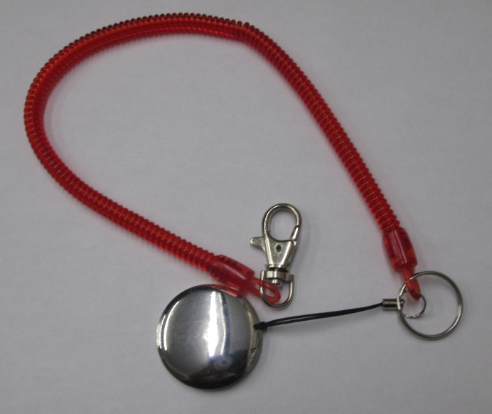
Figure 1: Safety Lanyard
The inboard will not operate if the safety lanyard is not in place. Ensure there is a spare one on board the boat and that passengers know where it is located.
- Motor Overload
- If the motor is excessively overloaded (by either extended running at high speed or using a propeller which is too big for the application) the motor will stop.
- If the motor stops all drive will be lost, which may be hazardous.
- If the motor stops, move the speed control lever to the stop position. Slowly move the speed control to the drive position which will start the motor again.
- Continue at a reduced speed until the initial cause of the overload has been resolved.
- Modifications
Do not attempt to modify the inboard motor as this is likely to reduce safety and reliability. Any modifications will mean that the inboard will not be liable for warranty and maybe illegal to use.
- Boat
- Ensure the boat, that the motor is being fitted in, has the capability of accommodating the power and weight of the unit. (including the batteries).
- Ensure that any requirements of the boat manufacturer are adhered to.
- Consider location of the batteries in regard to weight distribution within the boat.
- Passenger Training
- Ensure that at least one Passenger is trained to operate the boat in the event of an emergency.
- Terminal Crimping
Ensure that a professional type crimping tool is used for crimping all heavy-duty cable connections. Failure to do so can result in poor performance, system failure, terminal overheating or in some cases melting of plastic terminal plugs or even fires.
- Applicable Standards
Ensure that the fitting and installation of the inboard electric drive motor, batteries, battery storage, cables and control systems comply with all relevant local, national, and international standards.

SECTION 2 – Identification

The unit serial number can be found engraved into the brass plate on the inboard.

An example of the identification plate is shown below (Figure 2):
 | Description
1 | Model
2 | Serial Number

SHIRE
6.5kW-XXXXX

2
1

Figure 2: Identification Badge

SECTION 3 – Component Identification
- 6.5kW Offset Electric Drive (Front)

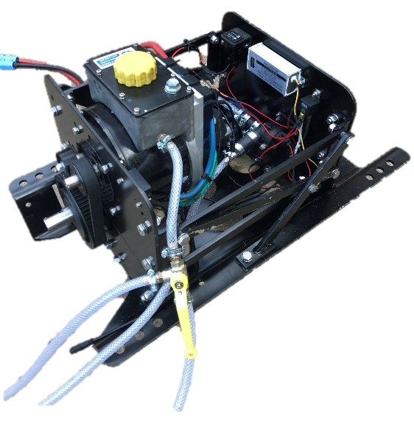
4
3
2
1
 | Description*
1 | Hour meter
2 | Voltage Converter
3 | Pump
4 | Bleed Tap
Figure 3: 6.5kW Offset Electric Drive (Rear)

- 6.5kW Offset Electric Drive (Rear)

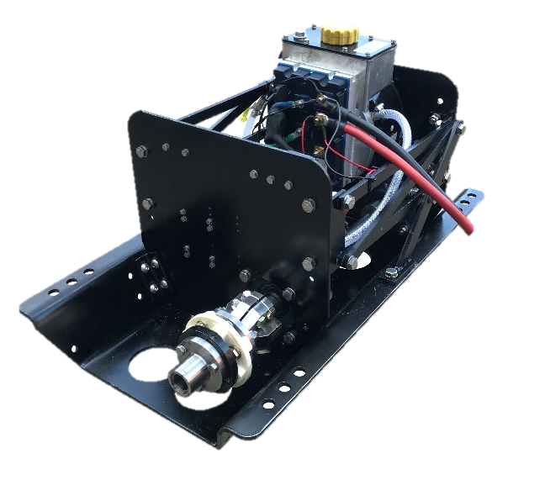
1
2
 | Description*
1 | Motor
2 | Output flange / flexy Coupling
Figure 4: 6.5kW Offset Electric Drive (Rear)

- Speed and Direction Control Lever
1
 | Description*
1 | Safety Lock Button
2 | Control Grip
3 | Connecting Cable
4 | Safety Lanyard
5 | Mode Switch
6 | On/Off Power Button
7 | Extension Lead Connecting Plug
8 | Extension Cable (3.1 Metres)
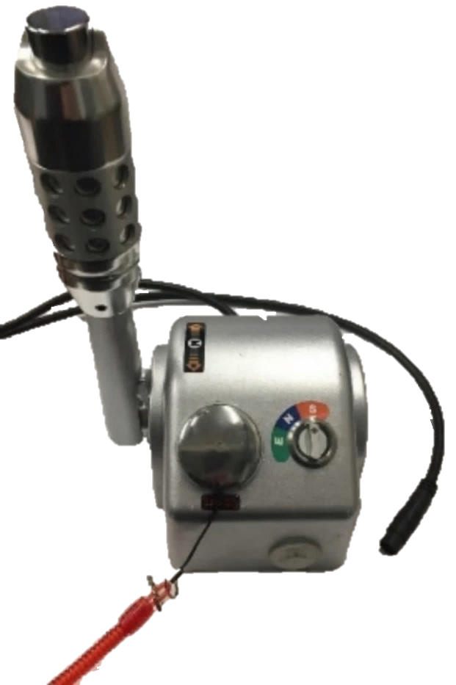
1
2
4
6
2

3

4
5
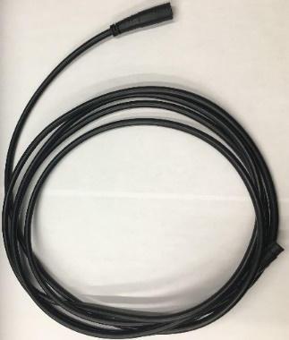
7
6

8
Figure 5: Speed and Direction Control Lever

Figure 6: Extension Cable

SECTION 4 – Installation

NOTICE:
REFER TO THE BARRUS MANUAL PRIOR TO INSTALLING THE ENGINE.
- Unpacking the Inboard Motor
- Check to make sure you have the following parts:
  - Inboard Motor
  - Anderson Type Cable Connector (Qty 1)
  - Safety Lanyard
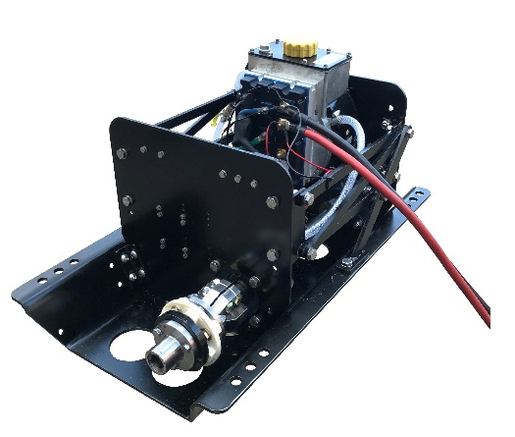
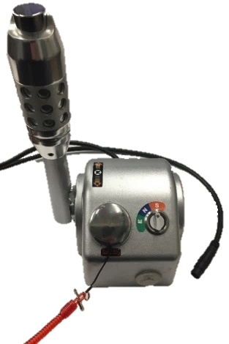
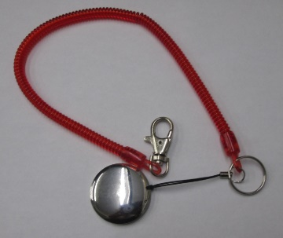
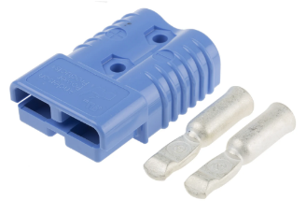
  - Speed and Direction Control Lever
1
4
3
2

Figure 7: Inboard Items
Note: There is a right-handed speed and direction control lever available at an additional cost.
- Filling the Inboard Motor with Coolant
- Remove the coolant cap from the inboard motor (
- Figure 8).
- Switch the inboard on, using the on/off switch (Figure 5, Button 6). The button will be illuminated green and the pump will start. Immediately start filling with coolant.
- Fill the coolant tank with standard high-quality antifreeze and clean water at 50:50 mix ratio.
Ensure the shifter is in the neutral position. Do not engage forward or reverse.
- After one minute switch off the power then add coolant again.
- Switch on the power again to allow the pump to circulate the coolant.
- These stages may need to be repeated multiple times to ensure the tank is full, and all air is removed.

Ensure the coolant tank is full before operating the inboard.

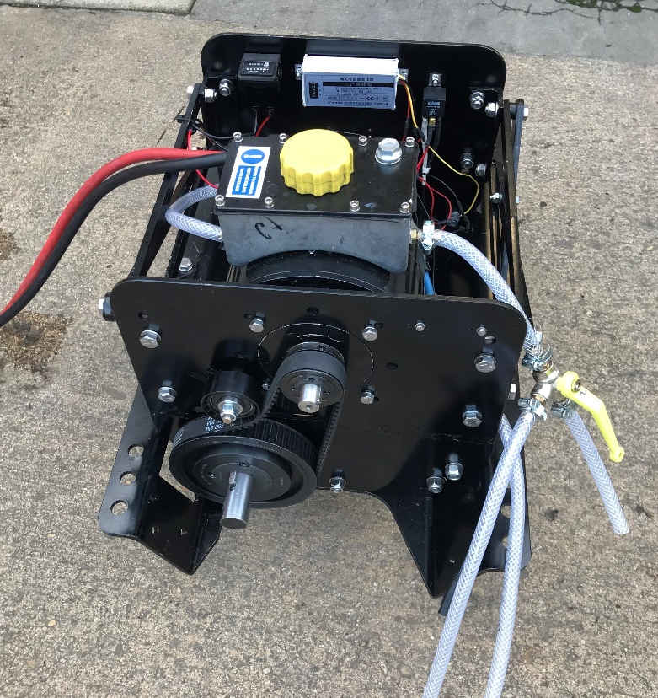

Figure 8: Coolant Cap
Ensure air bubbles are removed before operating the inboard.

- If air bubbles enter the system, cooling will be compromised. The bleed valve (Figure 9) can be used to remove air bubbles.

Figure 9: Bleed Valve
- Battery Selection
- There are many types of battery available that can be used with this range of electric inboards. It should be noted that they should be deep cycle traction and of the correct voltage (48 Volts).
- The inboards will be set up to work with lithium-ion polymer batteries, however the settings can be changed to better suit lead acid batteries, lead carbon, gel type, or similar. The lower the cut off voltage for the batteries, the more likely they are to get damaged.

Care should be taken when switching from lead acid to lithium-ion polymer batteries, as the settings of the controller may need to be re-programmed. Such programming can only be carried out by an authorised dealer, using a computer.
- The size of the battery bank required to power the inboard motor will depend on the current draw you plan to regularly place upon it and the distance you plan to travel. It is difficult to determine the current draw until the inboard motor is used as each boat has a different hull shape, length, displacement, speed, and daily operating cycle requirement. Only one 48V Barrus battery module is required to run the boat at 6. Additional battery modules can be added to increase the range. Battery modules can be easily connected in parallel to form a larger capacity battery bank.

If using batteries from other manufacturers or sources, these may be either 12v or 24v. The batteries must be connected in such a way as to give 48v.

Always use Blue Anderson type connector plugs for 48 Volt batteries and connecting cables to avoid potential injury and/or damage to the battery and inboard.

Note: Different coloured Anderson type connectors are used for different voltages to avoid connecting batteries of the incorrect voltages.
- Connect the battery to the inboard as per Figure 10.

A battery isolator must be fitted between the battery and the motor.
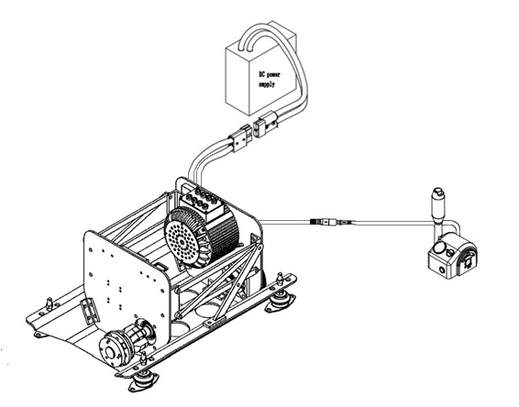
Isolator Switch
Figure 10: Battery Connections
- The table below shows the minimum battery and equipment specification required for the inboard motor.
- To stop safety risks, capacity losses and contact point losses, only the same type of batteries (same manufacturer, same capacity, same age, and same charge condition) should be used together.
Model | Minimum Cable Size | Minimum Battery Isolation Switch Specification
5kW EZ Inboard | 25mm² | 300A 48V

Differences in the charge condition of batteries wired in series can cause high compensatory currents or overloads which can damage the cables, connectors, or battery. In extreme situations this can cause fires and injuries.
- Battery Type Selection
- Customers may source suitable batteries locally. Please ensure that the battery manufacturer’s instructions are followed and adhered to.
- Optional battery types are available for use with these motors.
- Ensure all of the instructions and precautions are followed when using these batteries.
- Anderson Type Connectors
- The cables for the batteries and the electric inboard are connected using Anderson type connectors (Figure 11).
- Alternatively, cables with correct crimped eyelets.

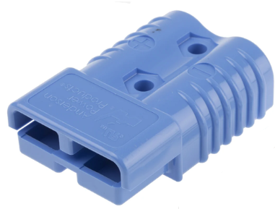
Figure 11: Anderson Type Connector

- The table below shows the specification of the Anderson type connector:

 | 6.5kW
UL Current Rating (Amperes) | 175
UL Voltage Ratings (Volts) | 600
AVG Contact Resistance (micro-ohms) | 100
Flammability Rating of Housing Material | UL94 V-0
- The Part numbers for the Anderson type connector is RDG206A48 (See Section 11 – Spare Parts)
*Note: See Section 1 – 12 safety precautions referring to terminal crimping.
- Battery Installation
- Ensure the batteries are stored in a well-ventilated compartment, that complies with the requirements of the R.C.D (recreational craft directive), UK regulations or other appropriate regulations.
- They must be covered to prevent damage and accidental short circuit of the cells, connections, and batteries.
- Batteries must be clamped down to prevent them from moving.
- Suitable connections must be used, the correct type of cable for the current carrying capacity, insulation properties and be of the flexible type.
- Every system must have a suitable battery master switch and main fuse to turn off and isolate the electrical system in the event of an emergency or when the boat is not in use. The switch for this must be readily accessible.
- The system also has a fuse (Circled on Figure 12) mounted on the main power inlet cable on the inboard.
Figure 12: Fuse Position
- Battery Storage
All batteries should be stored in a warm/dry environment, fully charged and isolated from the inboard electric drive.
- Connecting Speed and Direction Control Lever
- The inboard electric drive comes with a speed and direction control lever.
- The plug on the Control Lever is connected to the plug on the inboard motor (Figure 13).

Ensure that the two plugs are correctly aligned.

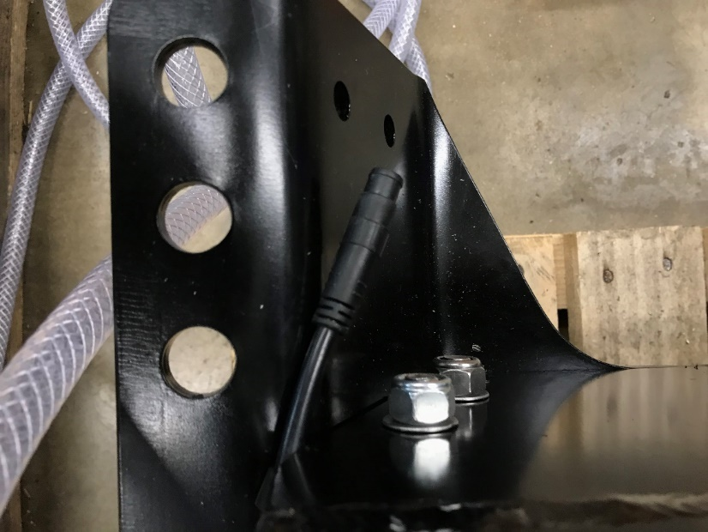

Figure 13: Control Lever connection

SECTION 5 – Operation

NOTICE:
REFER TO THE BARRUS MANUAL PRIOR TO OPERATING THE ENGINE.

- General
- Familiarize yourself with the electric inboard controls. For example, you must be able to stop the electric inboard quickly if required, or in an emergency.
- The electric inboard should only be operated by adults who have been instructed on how to operate the inboard and have read this manual.
- Follow the boat manufacturer’s instructions on the acceptable inboard maximum weight and power output for the boat. Don’t exceed the capacity limits.
- Stop the electric inboard immediately if someone falls overboard.
- Do not submerge the electric inboard motor, controller or other electrical items in water.
- After use, turn off the connection between the motor and the battery using the main battery isolation switch. This completely cuts the power supply to the electric inboard which will help prevent the batteries from discharging when the inboard is not in use.
- For manoeuvring in close to shore or pontoon the three-mode switch should be in the E (economical) position to ensure slow and steady control of the inboard.

- Starting Procedure (Speed and direction control lever)

- Ensure that the lever is in the neutral position.
- Attach the safety lanyard to the control lever connected to the inboard (Figure 14).

Locking Safety Button

Safety Lanyard

Power (on/ off) Switch

Figure 14: Safety Lanyard attached to control lever
- Attach the other end of the safety lanyard to the operator’s life jacket or leg.

The inboard will not operate if the safety lanyard is not mounted in its correct position.

*Note: The lever must be installed to move the boat forwards when the lever is moved forward.
- Press the power button. The light on the button will illuminate green and the cooling pump will switch on.
- Press the locking safety button on top of the lever down.
- Slowly push the speed and direction control lever in the direction required (forwards or backwards) to start the inboard.
- To increase the speed, move the speed and direction control lever further forwards.
Figure 15: Speed and Direction Control Lever in forward position
- Stopping Procedure (Speed and direction control lever)
- Put the speed of the motor to the neutral position using the control lever. This will stop the propeller.
- Press the power button and the light on the button will go off.
- Application Downloads and Information
- EZ offers a FREE Smartphone meter display app, which is supported by both Android and Apple iOS. The app can be downloaded from the respective links (Download EZdashboard.apk (2.3MB))( App Store URL: Install EZoutboard-UI) alternatively the app can be downloaded from the Electric Inboard page of https://goldenmotor.com/
- The app allows users to track the motors speed, current and power. It also enables the logging of journeys and setting the maximum rpm limits as a percentage across the three modes.
- The speed logged can be shown in either km/h or mph.
- The Bluetooth adaptor dongle should already be in place when the inboard arrives.
- If it is not in place: - Ensuring your inboard electric drive is turned off and disconnected from the battery, carefully remove the lid. Locate the Bluetooth adaptor port, pictured below. Lift the rubber cover and insert the Bluetooth adaptor dongle into the six-pin male plug. Ensure there is adequate space around the motor and propeller before turning it back on. Upon restarting, the light on the end of the dongle should flash green.

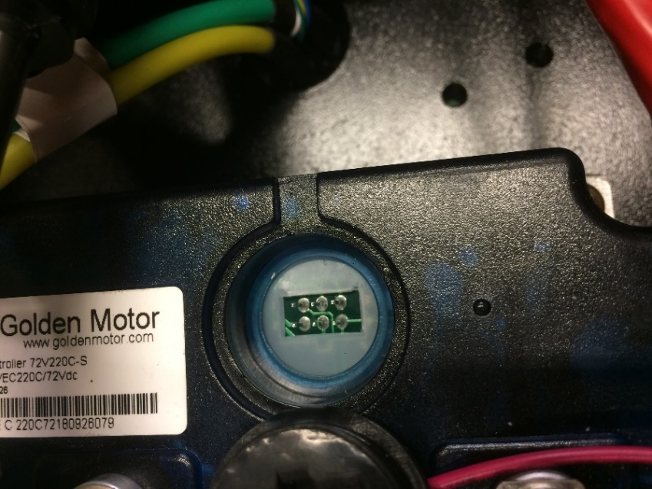
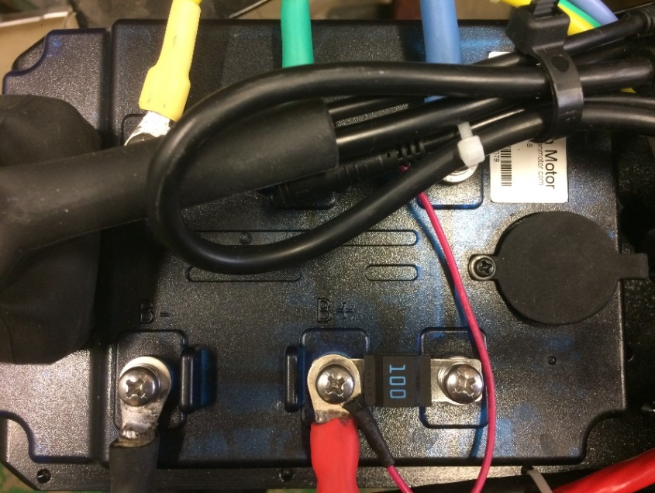

Figures 16 & 17: Bluetooth Connection
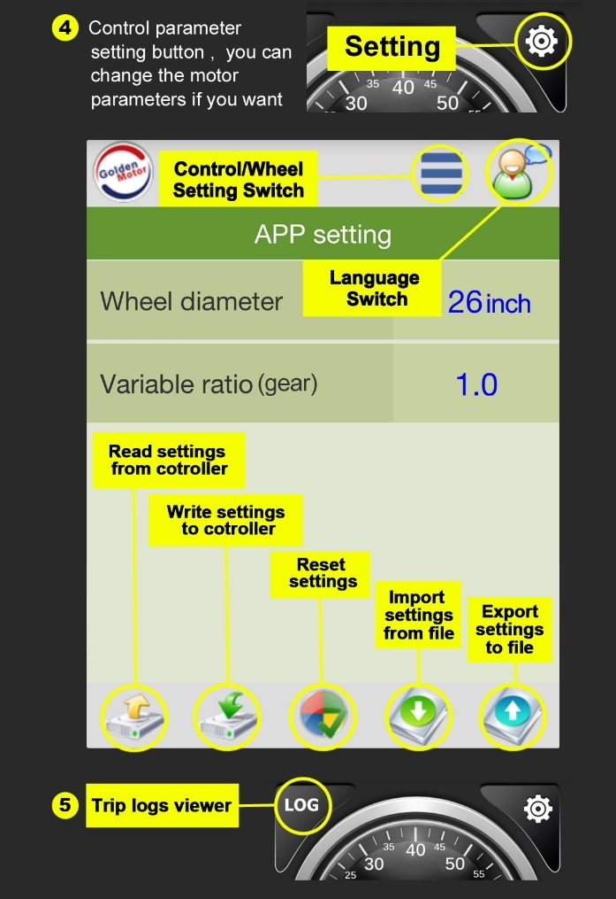
- After you have connected the Bluetooth adaptor, replace the lid.

Figures 18 & 19: App Manual
Note: Often the motor will appear as “LDMC” or similar on the in-app Bluetooth menu.
Note: The app may appear in a different layout on the iPhone version.
- The log section of the app allows users to download a spreadsheet with information about the motors speed, current and power as well as the motor and controller temperatures.
- The time interval (in seconds) between logs can also be adjusted using the settings tab.
- The app has the ability to set the 3 modes to different percentages of maximum throttle. The default for each of the three modes is: Economic- 25%, Normal 60% and Sport 100%. These can be altered to the desired percentages at your own discretion. To do so, open the settings tab as explained in part 4 above. Toggle along the top to the 3-Gear Settings tab. Here you can adjust each setting ratio. Once changed you can then upload this to the motor by clicking the cloud button at the bottom. This can be seen in the picture below.
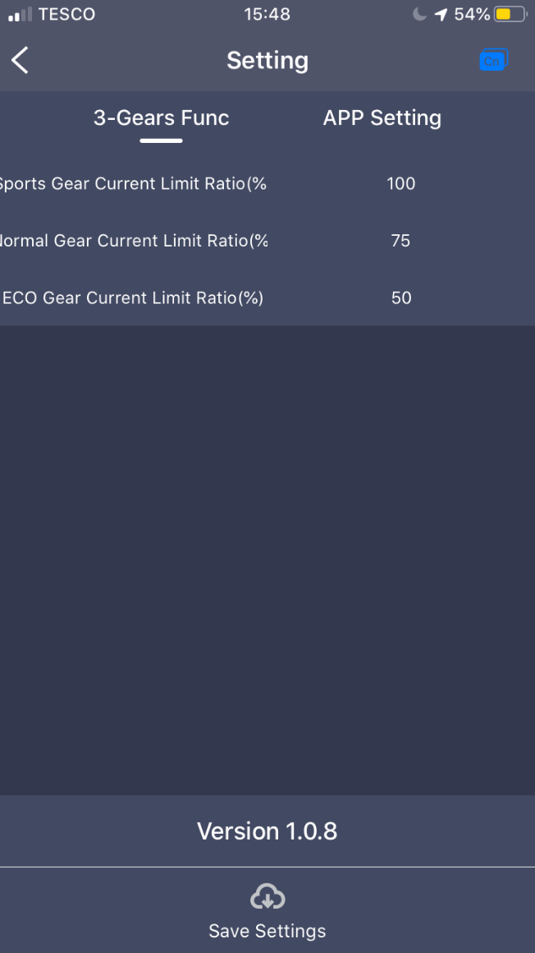
- Once uploaded the motor will continue to beep constantly until it has been restarted. Doing this, sets the maximum speeds for each mode limit.

Figure 20: Setting Inboard Speeds

- Once the settings have been uploaded to the inboard, they will not change unless modified through the app, even if the battery is disconnected.
- In a hire boat situation, once the settings have been made, if the Bluetooth dongle is removed the settings are locked and cannot be altered by the hirer.
- The phone will disconnect from the inboard if it is moved out of range, the application is closed, or Bluetooth is disabled on the phone.
*Note: The screenshots in this manual show the app as it appears in version 1.0.8. Future versions may have new features and could look different.

SECTION 6 – Maintenance

NOTICE:
REFER TO THE BARRUS MANUAL PRIOR TO CARRYING OUT ANY MAINTENANCE WORK.

WARNING:
PRIOR TO CARRYING OUT ANY SERVICE OR MAINTENANCE WORK MAKE SURE THE RELEVANT PERSONAL PROTECTION EQUIPMENT IS WORN.
- General
- The person who is to carry out the maintenance of the inboard motor needs to have the relevant mechanical and electrical competence to do so. If you do not have the relevant skills or tools it is recommended that the maintenance is carried out by your local dealer or qualified mechanic.
- The maintenance may involve being in the proximity of moving, hot or electrical parts. To reduce the risk of injury always make sure the motor is switched off and the battery is disconnected.
- If replacement parts are required always use genuine parts or parts of the equivalent design and quality. A list of replacement parts is in Section 11 - Spare Parts. Please contact your local dealer to order the replacement parts.

SECTION 7 – Transportation and Storage
- Transporting
- When the inboard motor is removed from the boat, set it down carefully.
- Storage
- Store the inboard motor in a well ventilated, dry storage area.
- The inboard motor should ideally be kept upright on a rack or trolley.
- When installed in the boat, ensure that the bilge is kept drained so that the unit does not become submerged.
- Ensure the storage area is kept above 0°c so that frost damage does not occur.

SECTION 8 – Wiring Diagrams
- Wiring Diagram for Offset Electric Drive

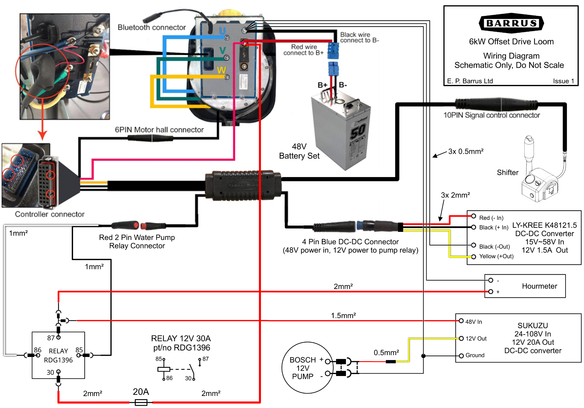
Figure 21: 6.5kW Offset Electric Drive Wiring Diagram
- Wiring Diagram for Speed and Direction Control Lever

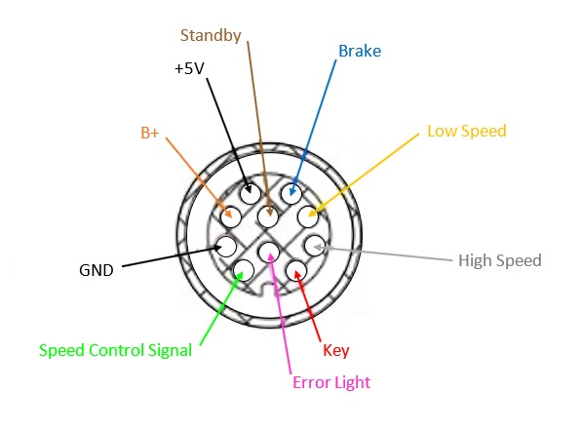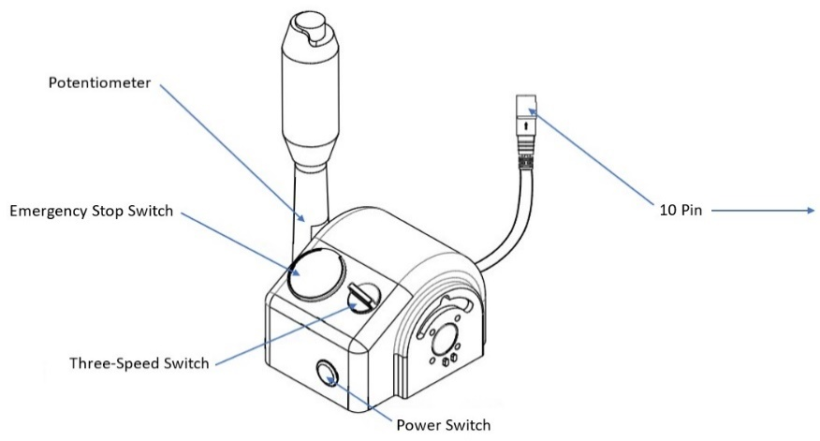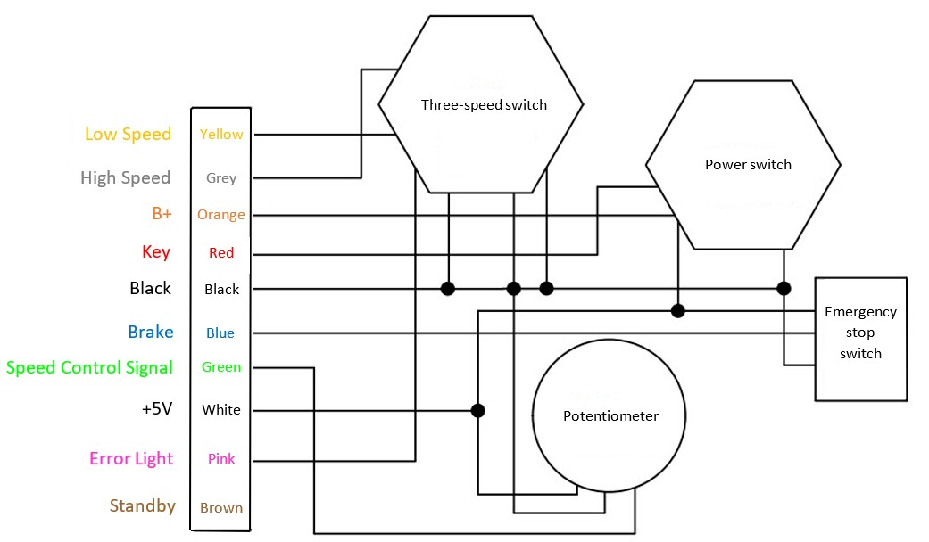
GND
Figure 22: Speed and Direction Control Lever Wiring Diagram

SECTION 9 – Technical Data
- Inboard Data
Model | Offset Electric Drive
Output (kW) | 6.5
Approximate Equivalent Diesel / Petrol Engine Power (hp) | 10
Voltage (Vdc) | 48
Input Current (A) | 135

- Dry Weight of Unit Data
Dry Weight of Electric Inboard
Model | Dry Weight (kg)
Shire 6.5kW Offset Electric Drive | 72.5

- Inboard Dimensions

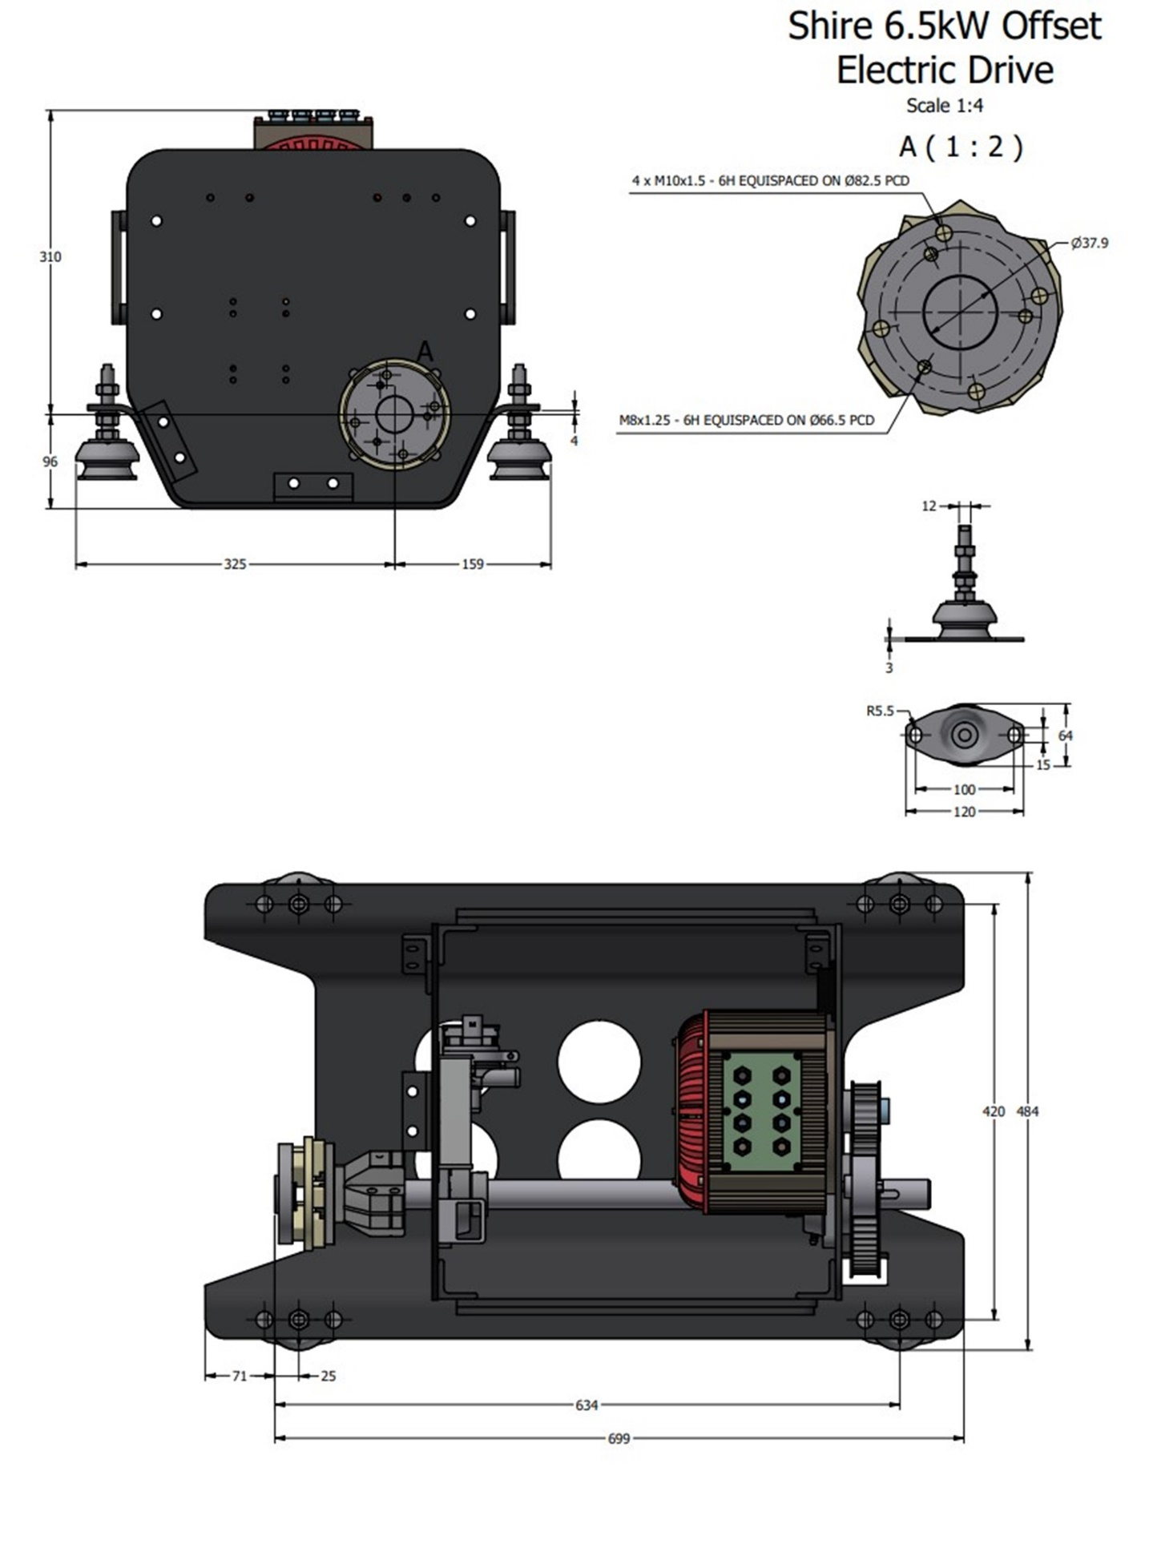
Figure 23: Shire 5kW EZ Inboard Drawing

SECTION 10 – System Protection Characteristics
In the event of the operating system receiving a fault code, the controller will sound out one of the following error codes via a number of beeps.
System Protection Feature | Description | No. of Beeps
Over–voltage protection | Battery voltage is higher than default value. | 1
Under-voltage protection | Battery voltage is lower than default value. | 2
Motor over-current protection | Motor phase is short-circuiting or phase to B+ is short circuiting. | 3
Stalling protection | The propeller is blocked by foreign matter. | 4
HALL protection | HALL input is abnormal. | 5
MOSFET (Transistor) protection | MOSFET self-checking is abnormal. | 6
Phase winding disconnect protection | One of motor wires is disconnected. | 7
Self-checking error protection | Self-checking is abnormal if internal system power is on. | 10
Controller over-heat protection | Controller operation temperature is higher than the default value. | 11
Throttle protection | Throttle input is abnormal. | 12
Motor over-heat protection | Motor temperature is higher than the default value. | 13
Throttle is not in the neutral position | Make sure the throttle is at “N”. | 14
Controller brake | The controller brake is applied | 15
Signal power protection | The controller signal power is abnormal. | 16

SECTION 11 – Spare Parts

Item | Picture | Shire 6.5kW Offset Drive
Motor |  | GM-HPM5000L EZ
Motor Controller | 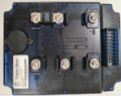 | GM-VEC7220
Controller Wiring Loom | 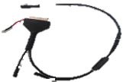 | GM-CA-201VEC
Fuse |  | GM-FS0002
Bluetooth Adaptor | 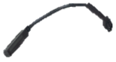 | GM-BL0001
Laptop Connecting Lead | 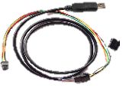 | GM-PI-400VEC
Anderson Type Connector | 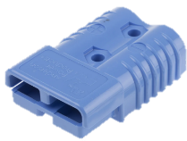 | RDG206A48
Scalable Battery Hub  (Multi battery connector with master on/off switch incorporated) | 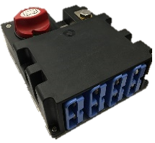 | GM-BH4X
Power Button Cover |  | GM-BC0001
Safety Key |  | GM-SF0001
Remote Throttle Set (Left Hand (Standard)) | 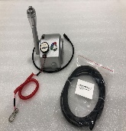 | GM-TRC-010L
Remote Throttle Set (Right Hand (Optional)) | 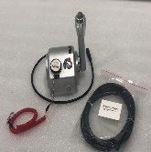 | GM-TRC-010R
Remote Throttle Cable (3m) | 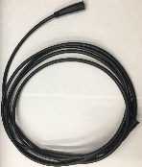 | GM-RT0002
Inboard Shifter Mounting Brkt | 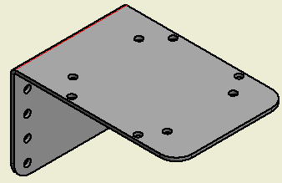 | RDG401A431
Quicksilver 2-4-C Multipurpose Marine Lubricant |  | 92-8M0121966
Throttle Potentiometer |  | GM-110E1305
DC-DC Voltage Converter |  | GM-DC12
Shire Engine Mounts | 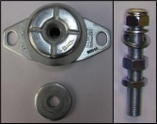 | RDG005A10
Flexible Coupling | 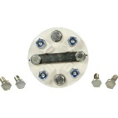 | RDG9129347
3 to 4 Bolt Conversion Plate | 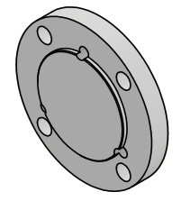 | RDG120B1

A Galvanic Isolator under part no 60110140 is available from Whisper Power:
https://www.whisperpower.com/power-distribution/galvanic-isolators-blockers
This can be used to mitigate galvanic action arising from a potential difference between the boat and the shore caused by a shore charging connection.
Special Tools

Item | Shire 5kW EZ INB
Motor Front Bearing/Seal Removal Tool | RDG701A69

SECTION 12 – Special Tools

Barrus offers service tools to assist dealers and mechanics.

- Motor Front Bearing/Seal Removal Tool (RDG701A69)
- Adjustable pin spanner for removal of motor front bearing and front seal.
- See Figure 25 for where to use.

Figure 24: Motor Front Bearing/Seal Removal Tool

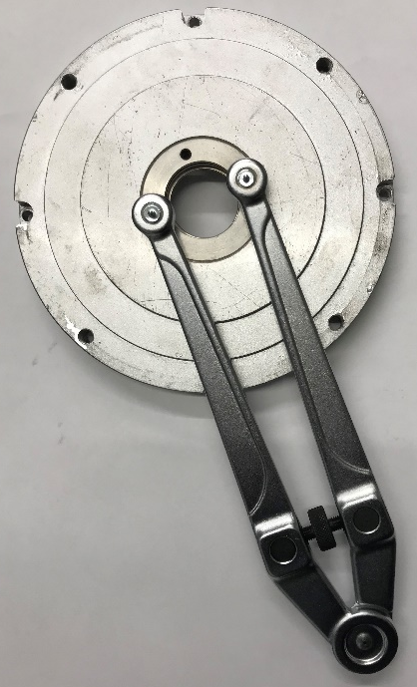

Figure 25: How to use Motor Front Bearing/Seal Removal Tool

SECTION 13 – Afterlife Recycling

When it becomes necessary to dispose of your machine, you must take it to your local Civic Amenity Site or recycling centre. For further information please contact your Local Authority for disposal advice.

Waste Electrical Electronic Equipment (WEEE) recycling.
Products containing WEEE waste which should not be disposed of in your domestic waste. You must recycle WEEE in accordance with your local authority or recycling centre.
Battery recycling: Batteries should not be disposed of in your domestic waste. You must recycle batteries in accordance with your local authority or recycling centre.

Reduce, Reuse, Recycle
Unwanted packaging materials should be sorted and taken to a recycling centre so they can be disposed of in a manner which is compatible with the environment.

For further information about disposal please contact your Local Authority. You can also get more advice and guidance about recycling at the following website http://www.recycle-more.co.uk.

SECTION 14 – Declarations
- LiFEP04 Battery TUV Safety Data Sheet
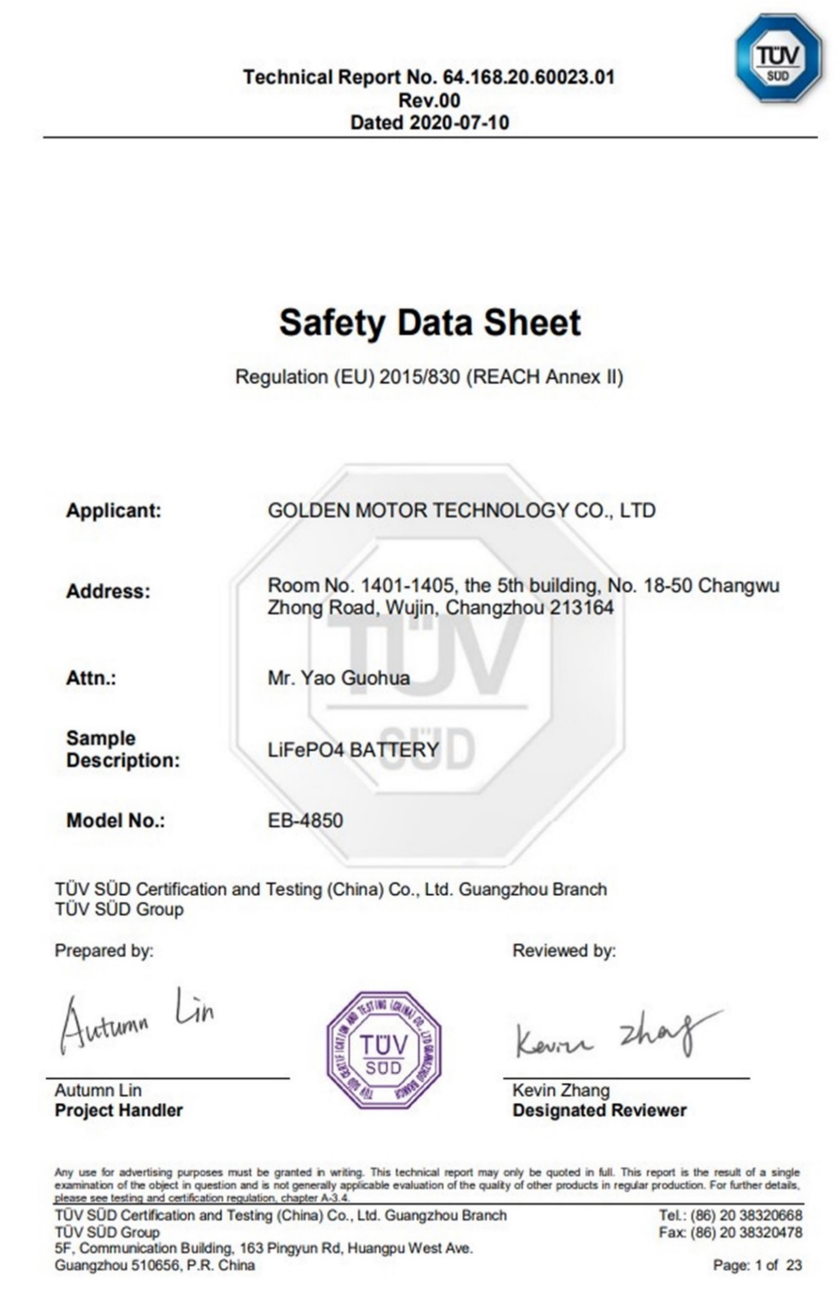
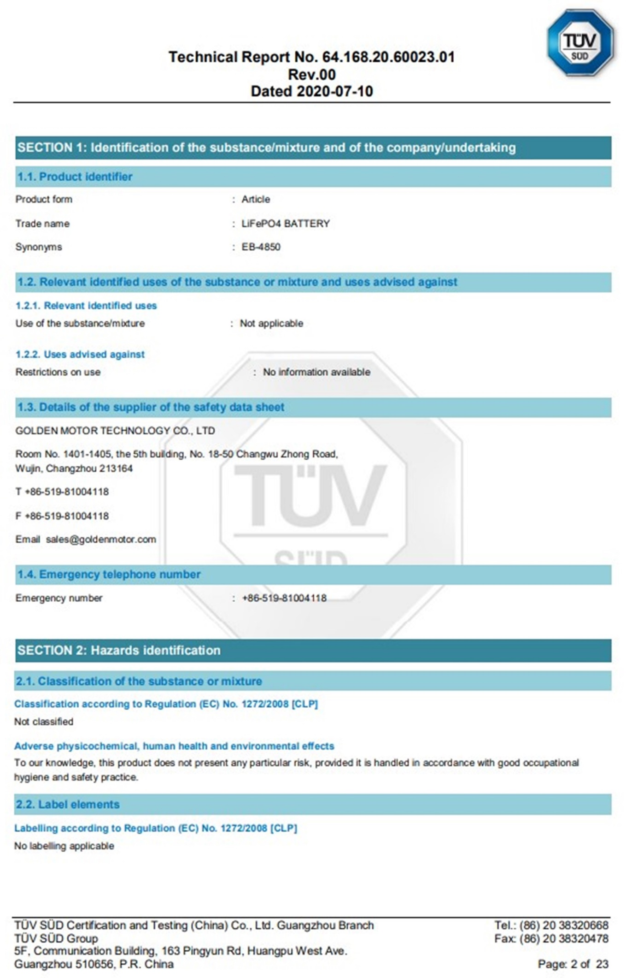
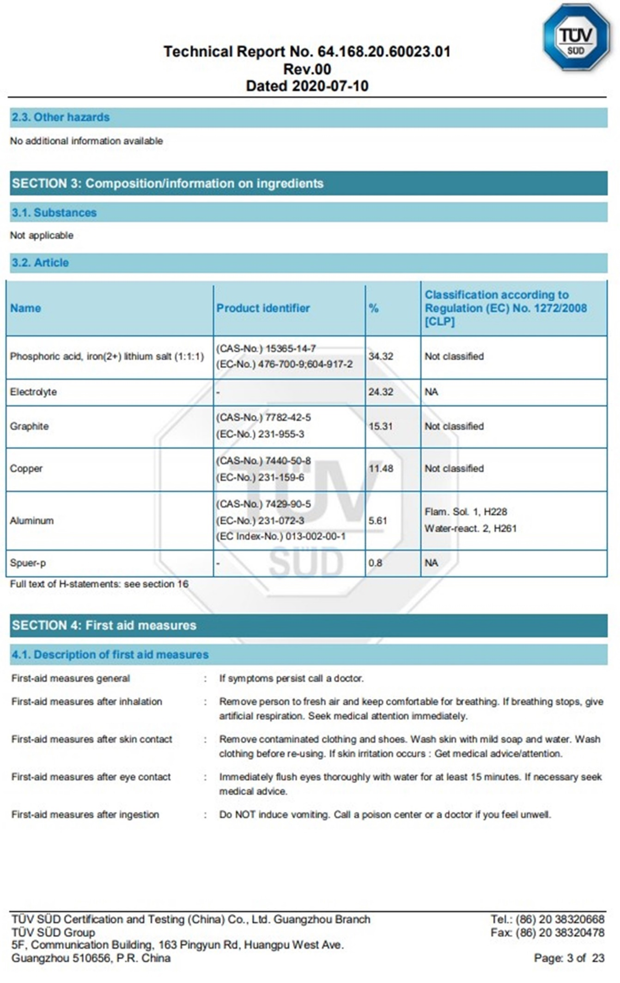
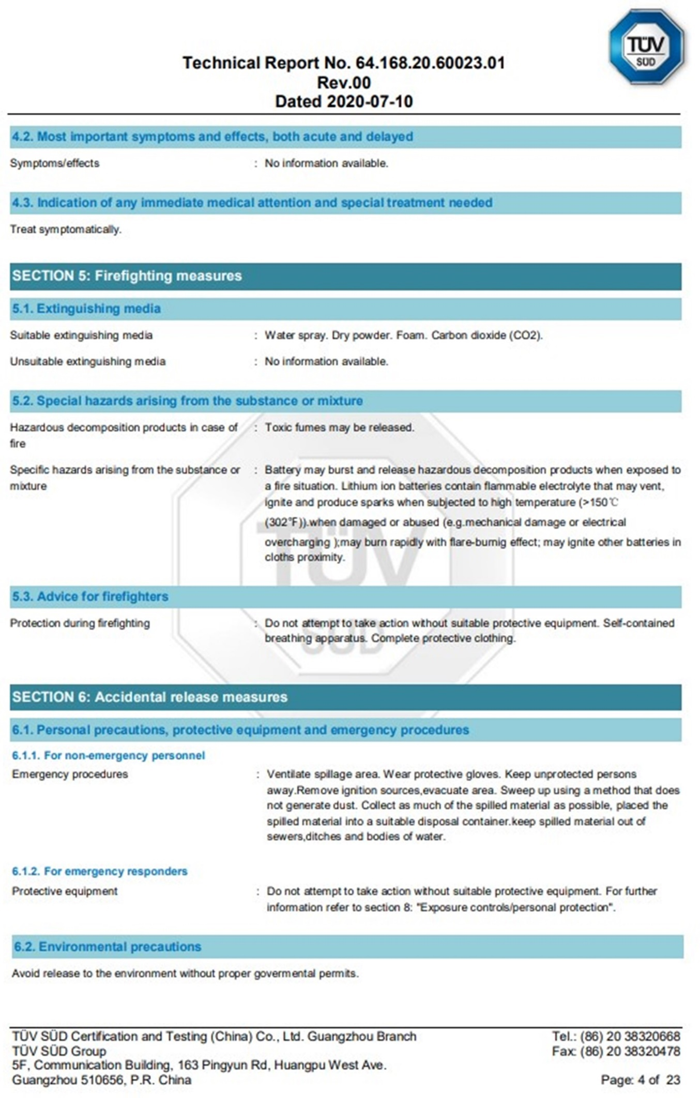
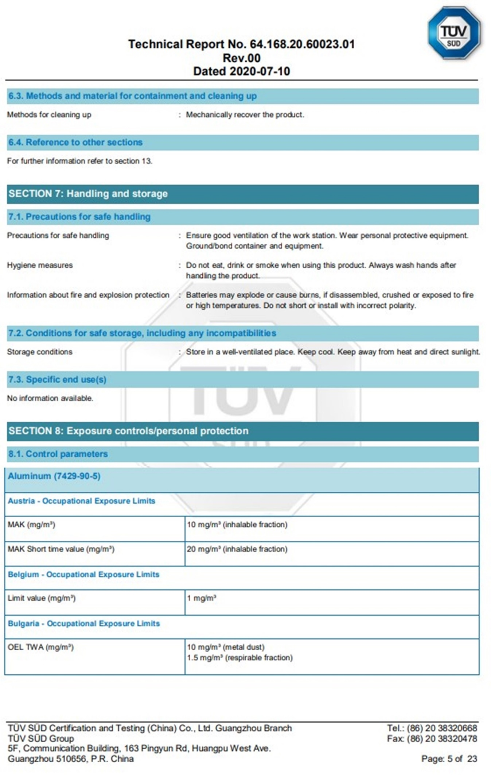
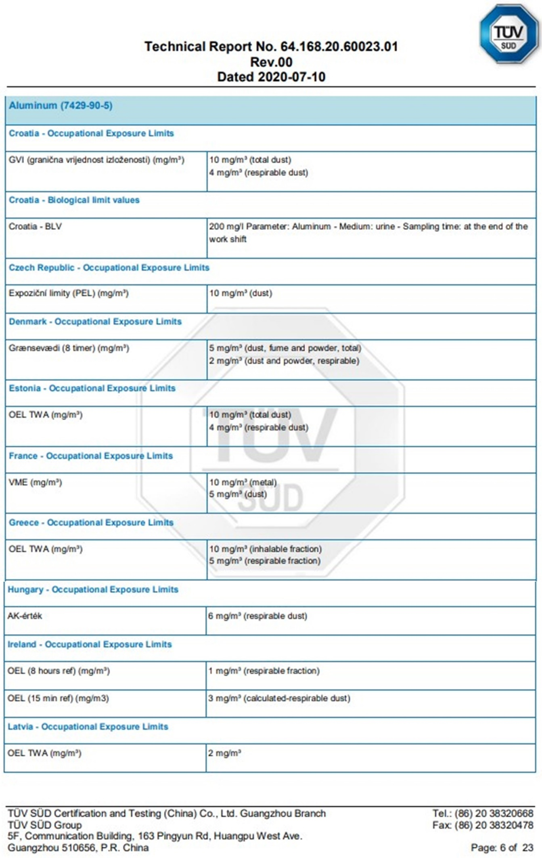
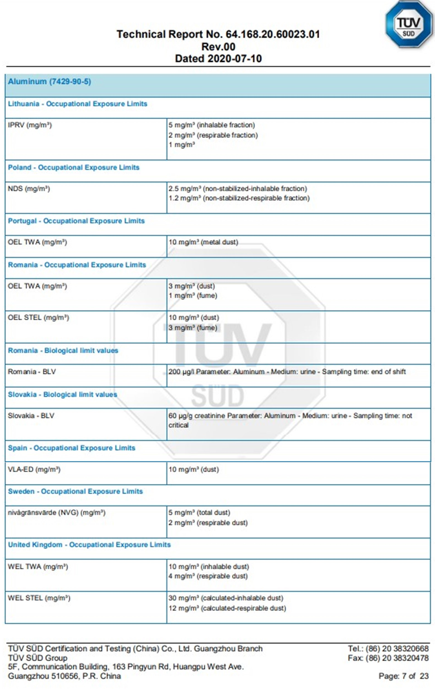
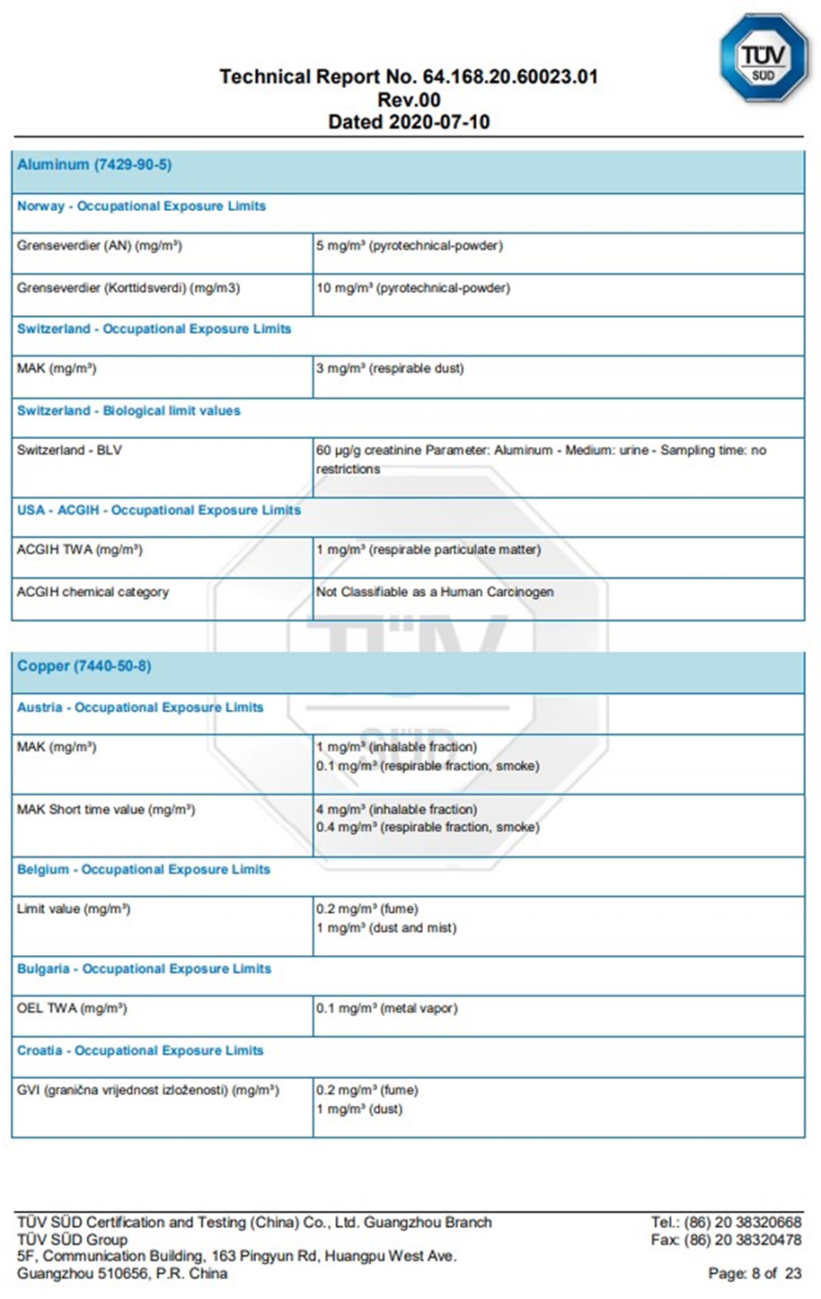
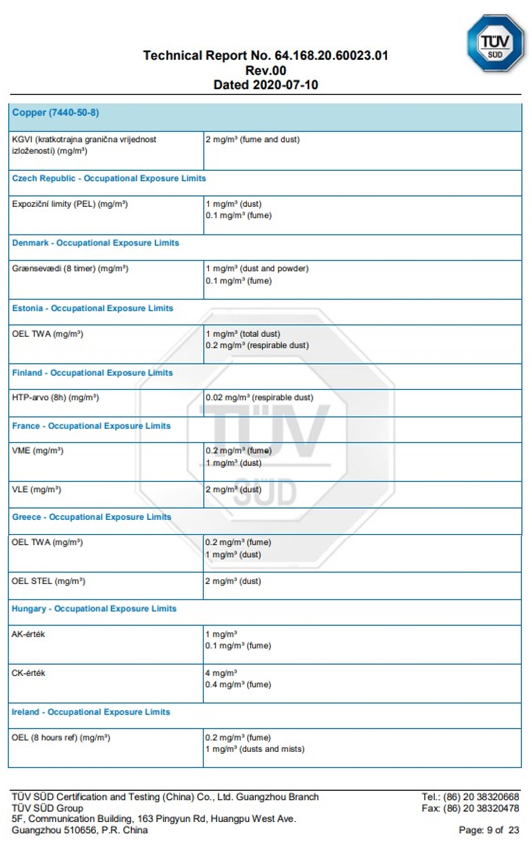
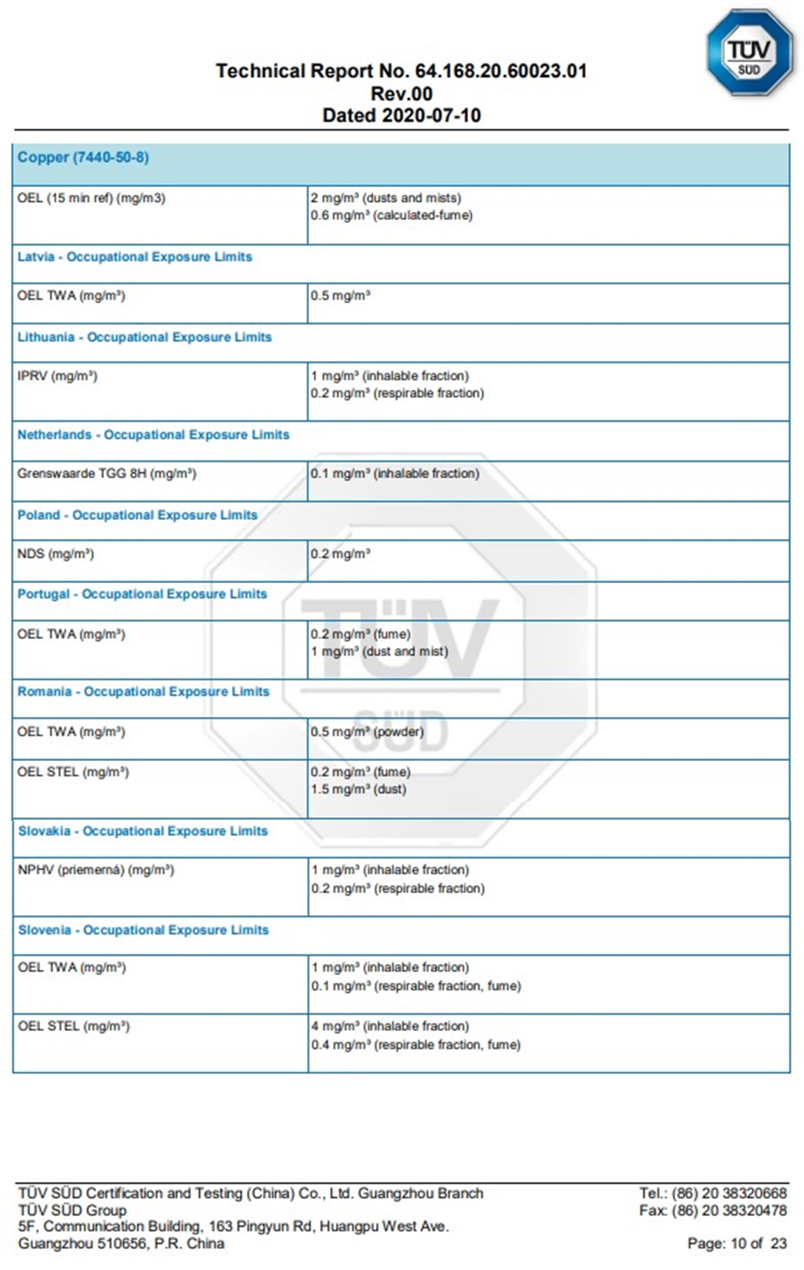
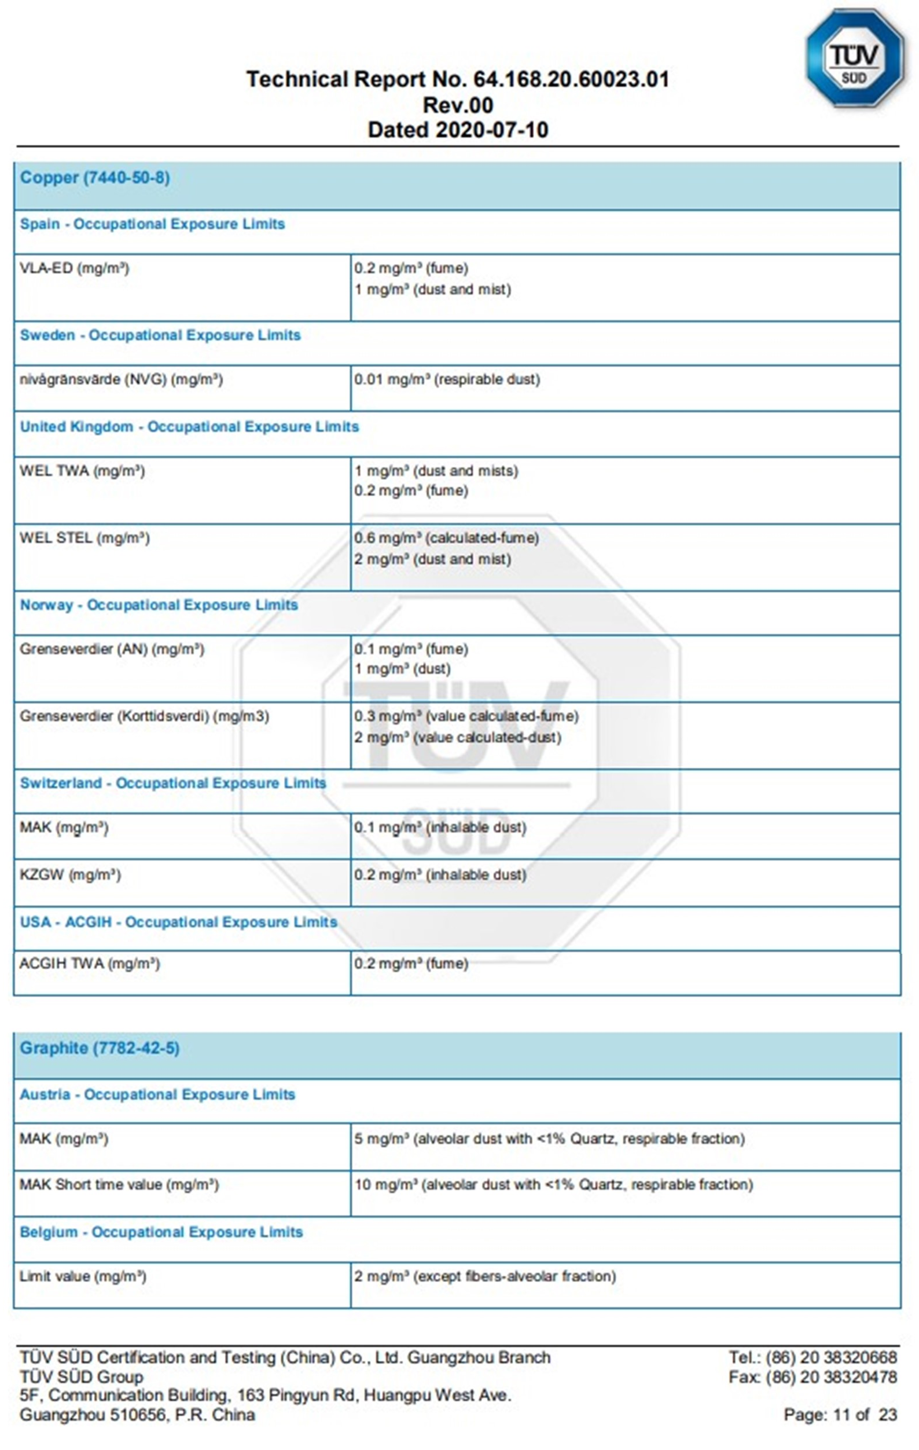
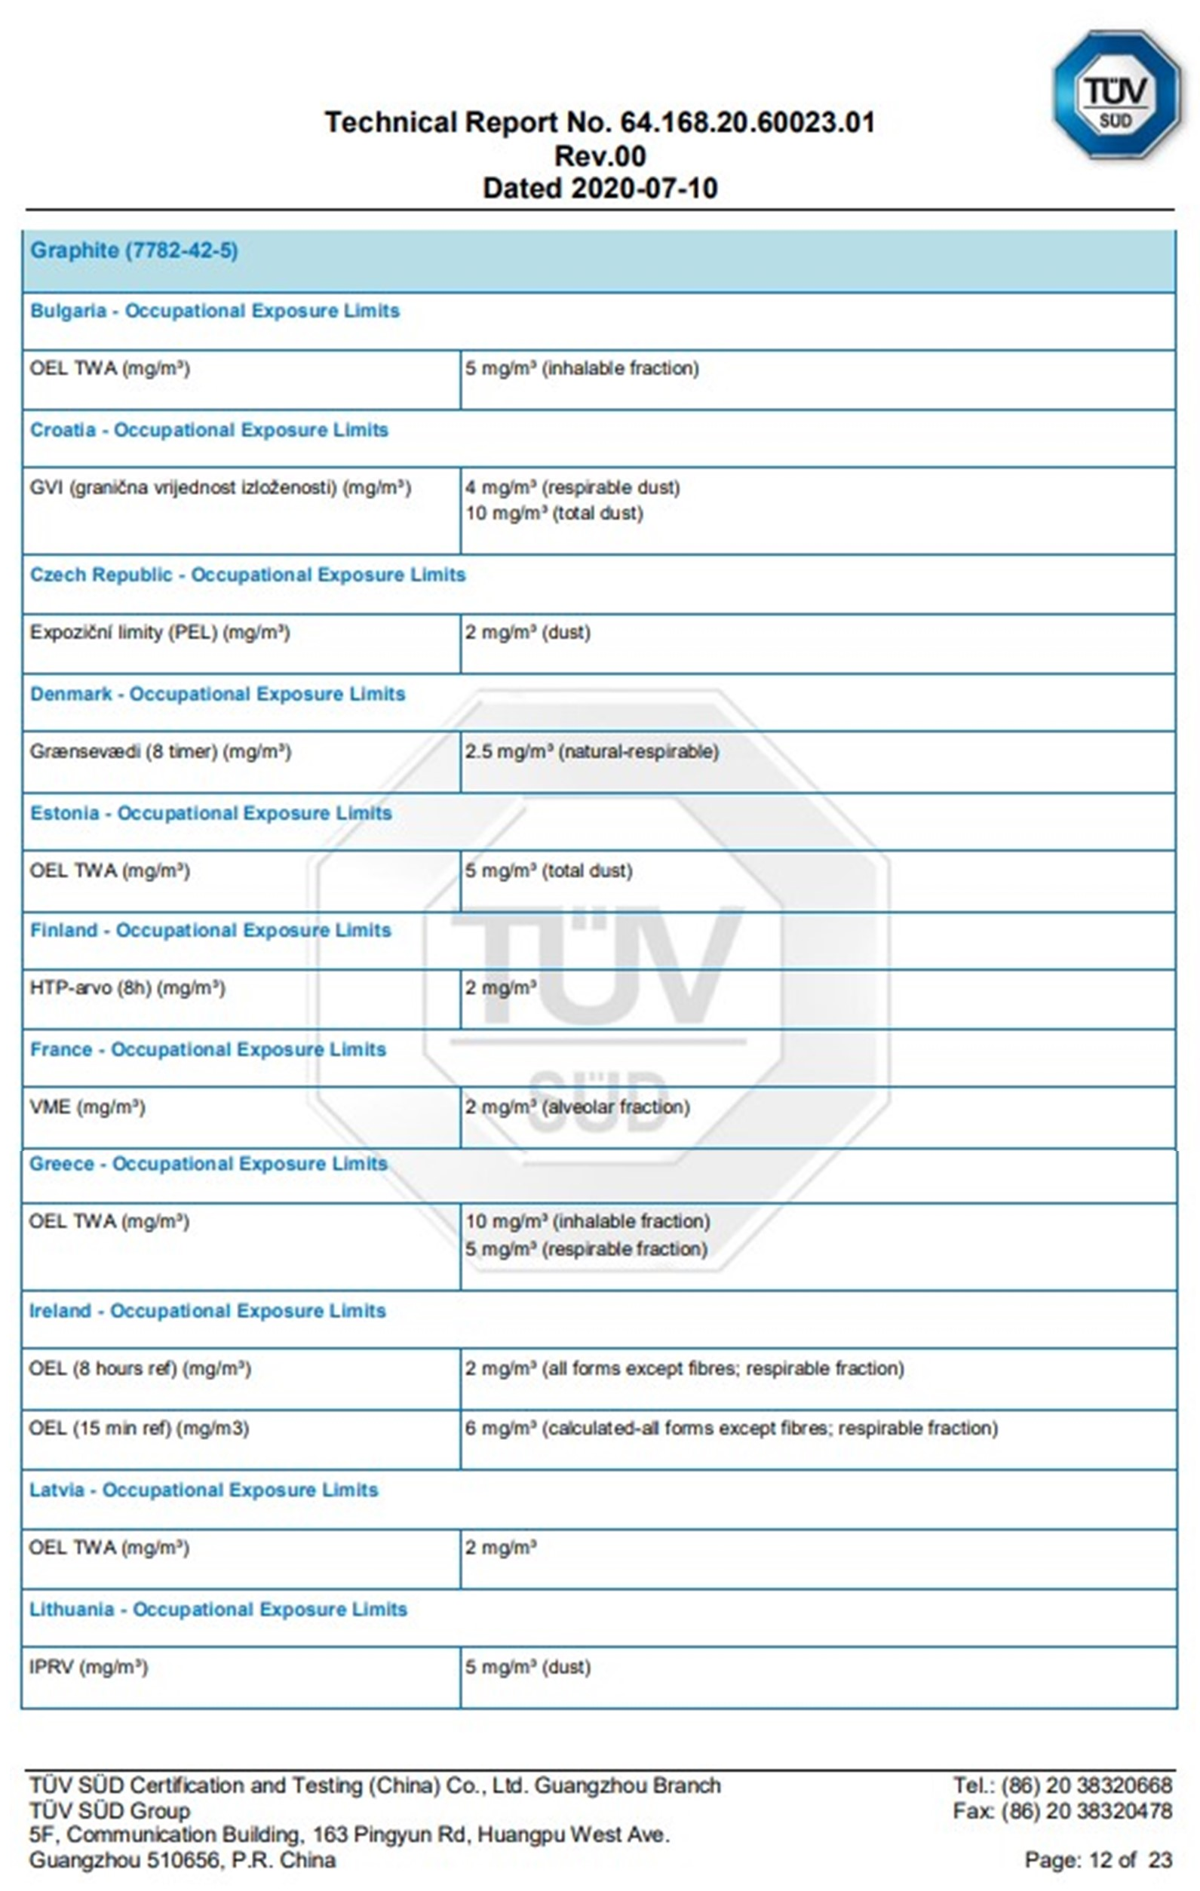
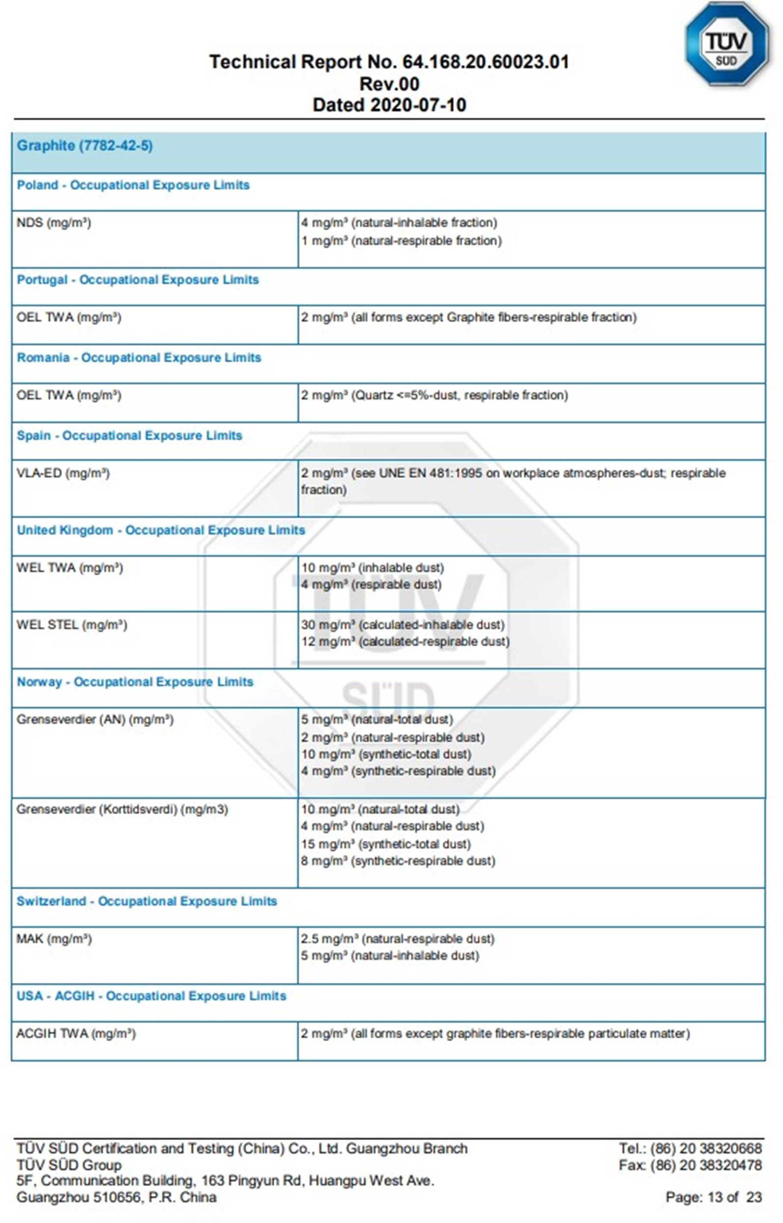
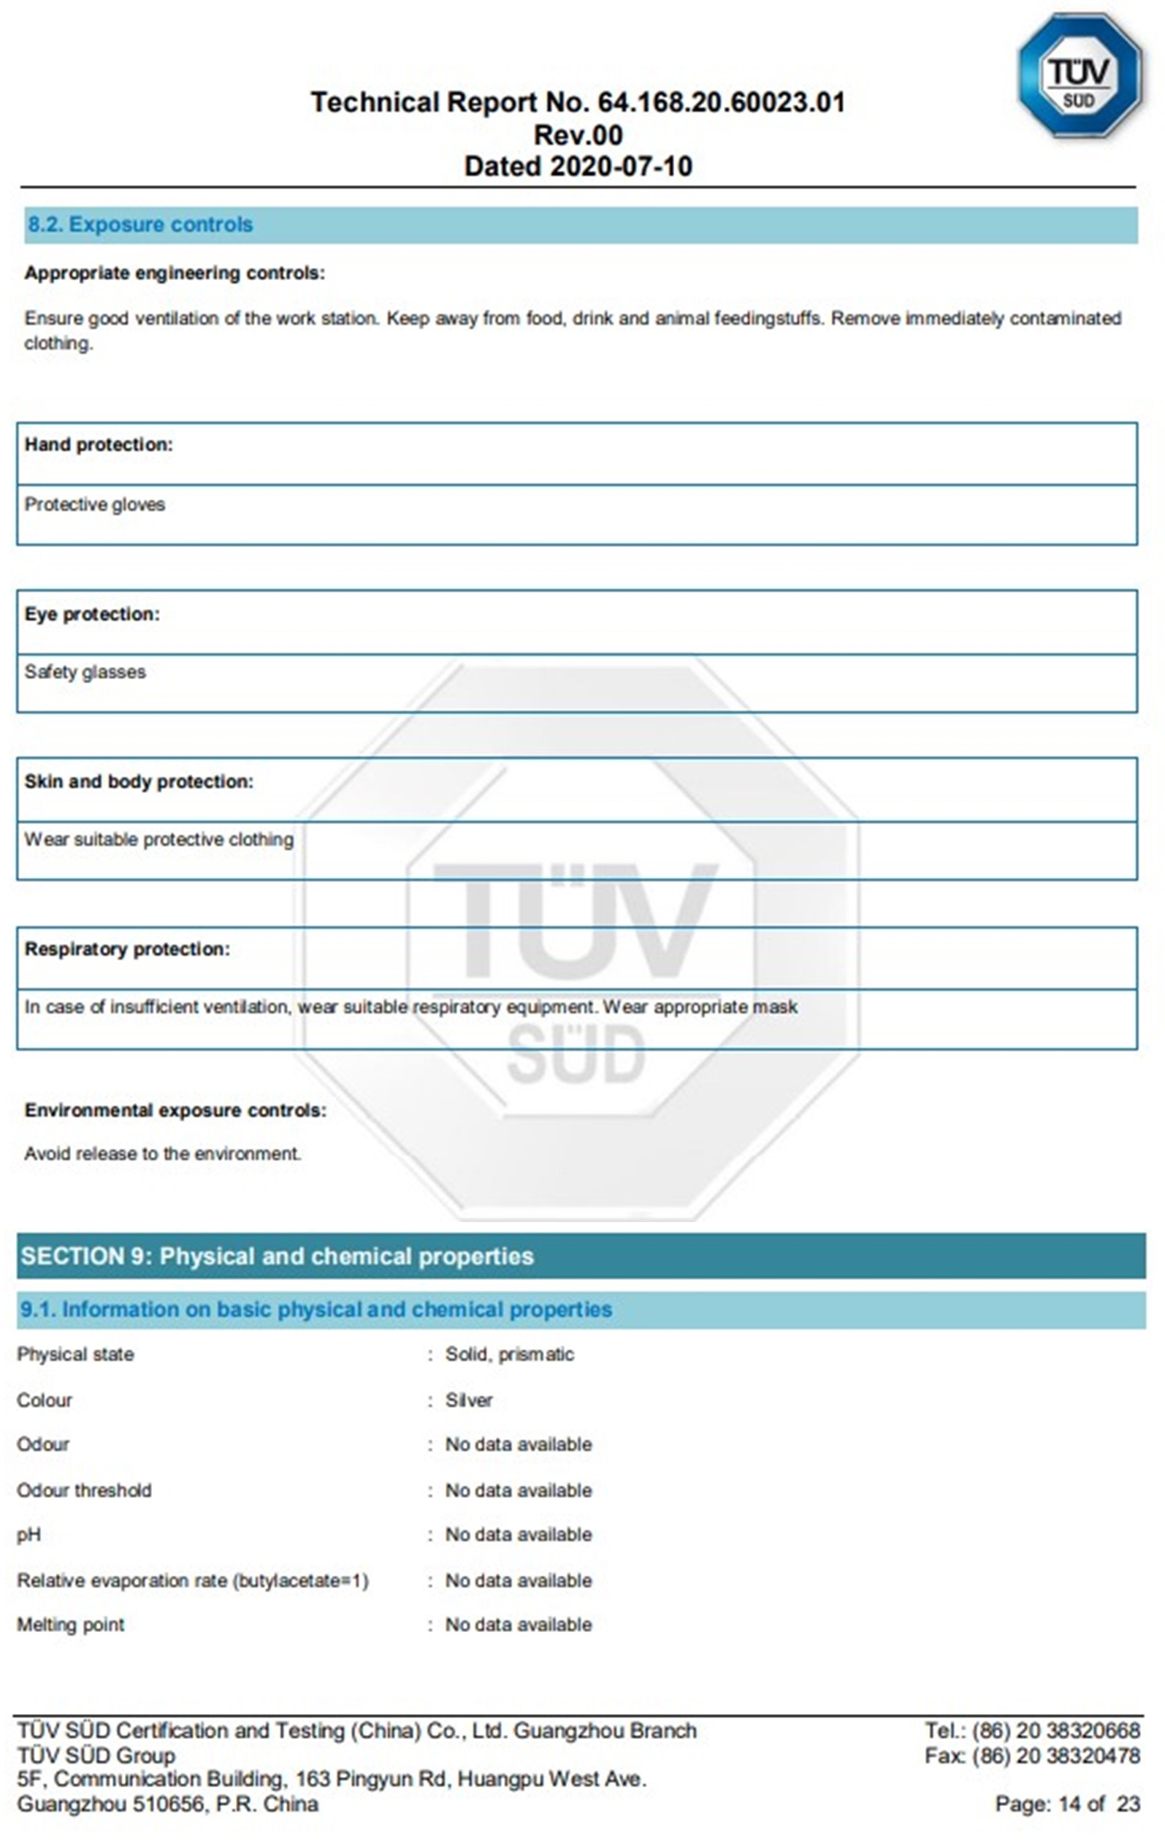
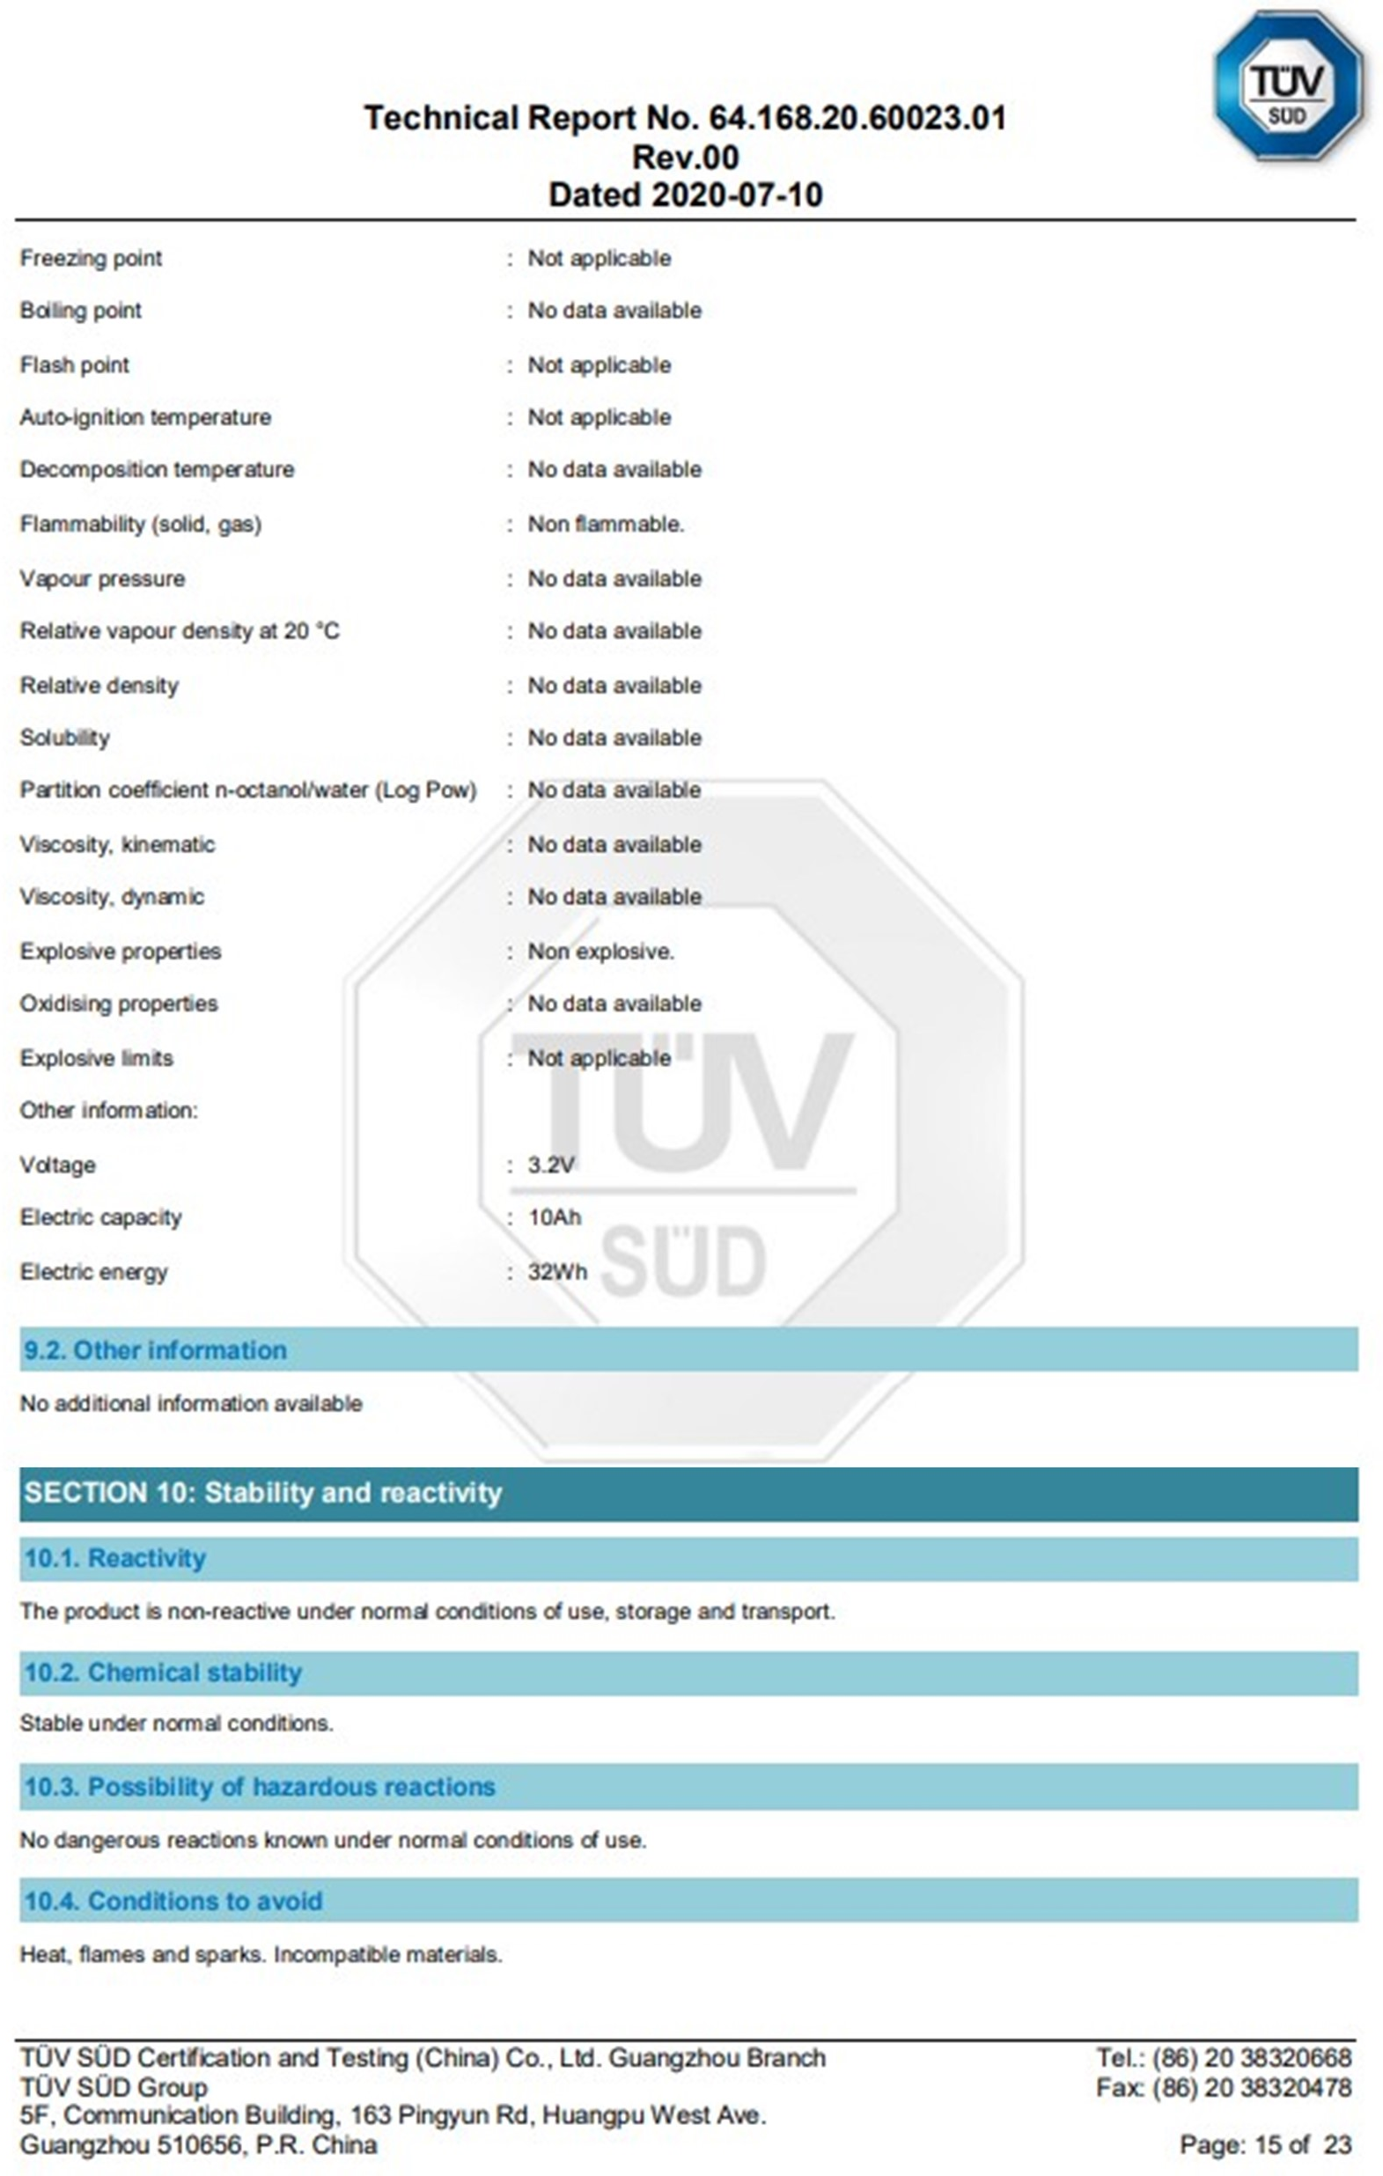
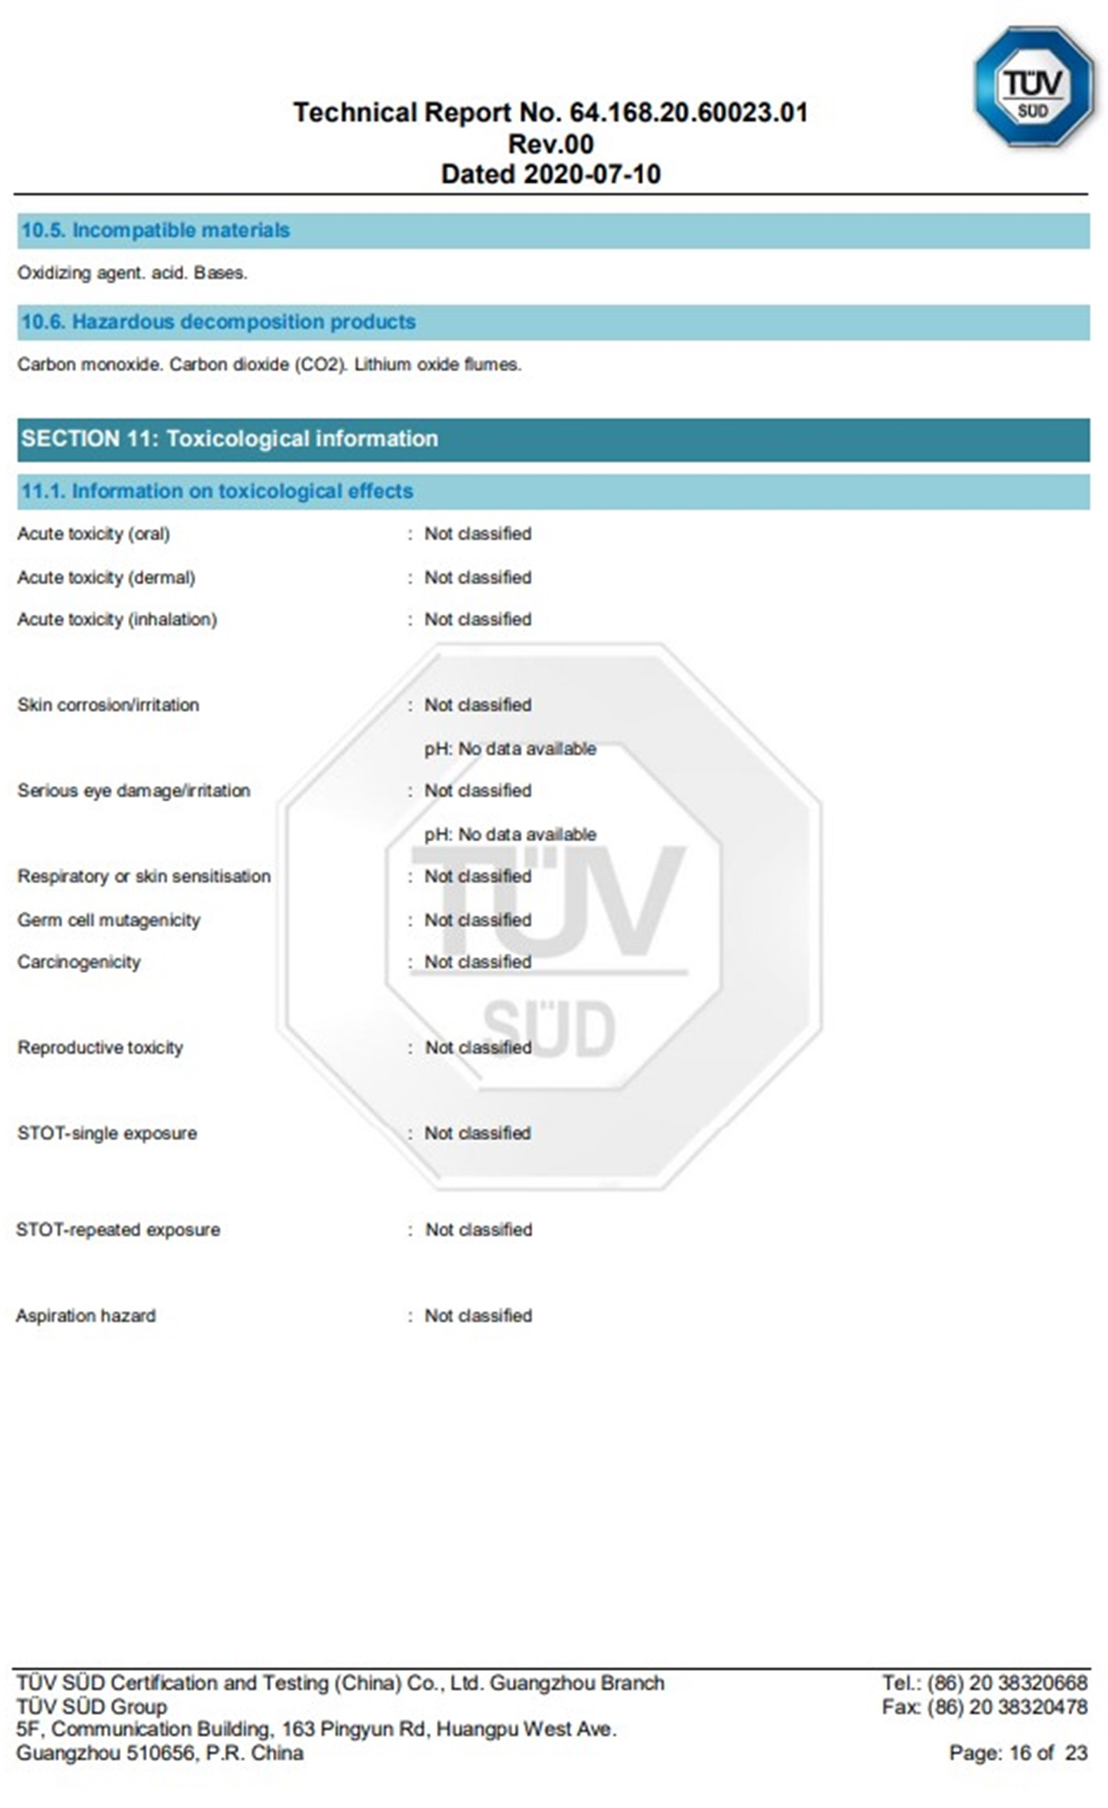
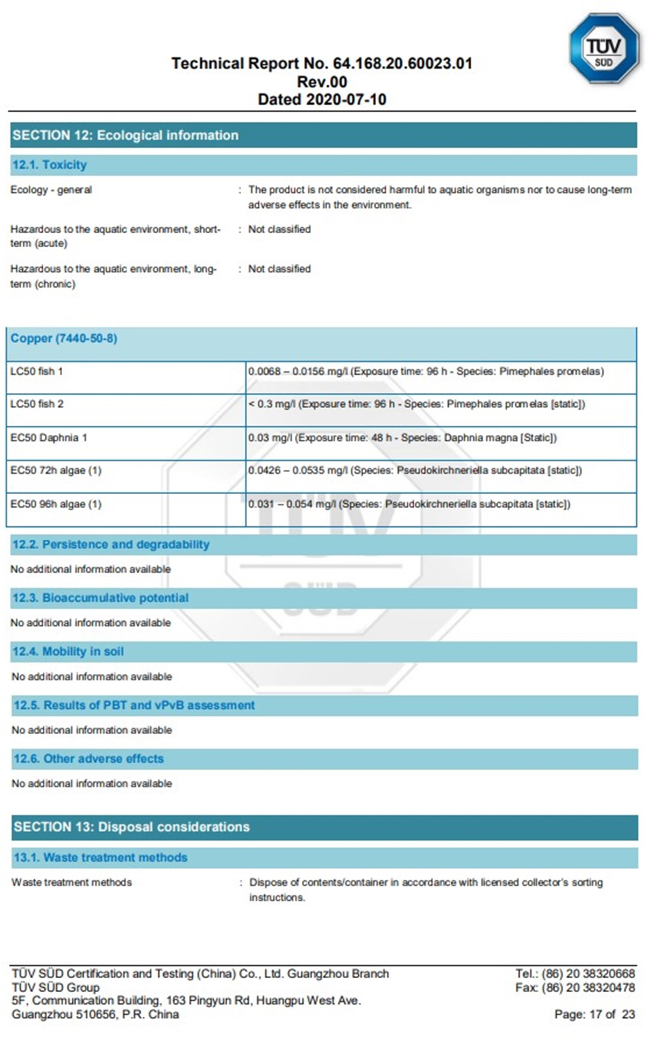
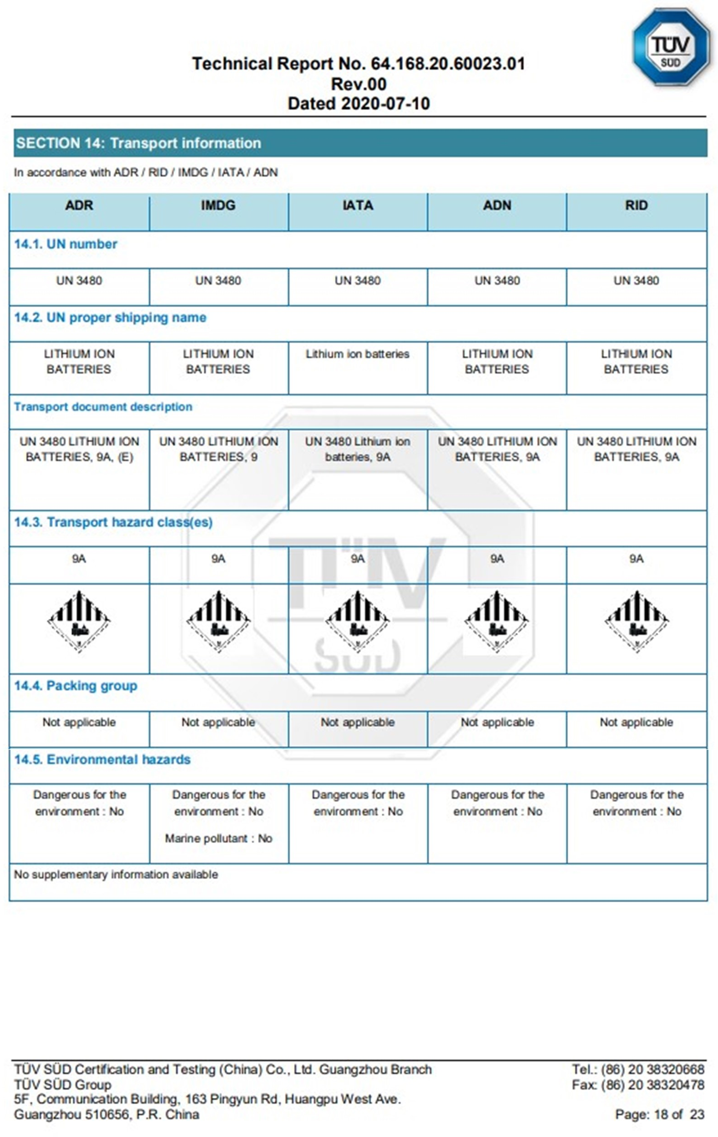
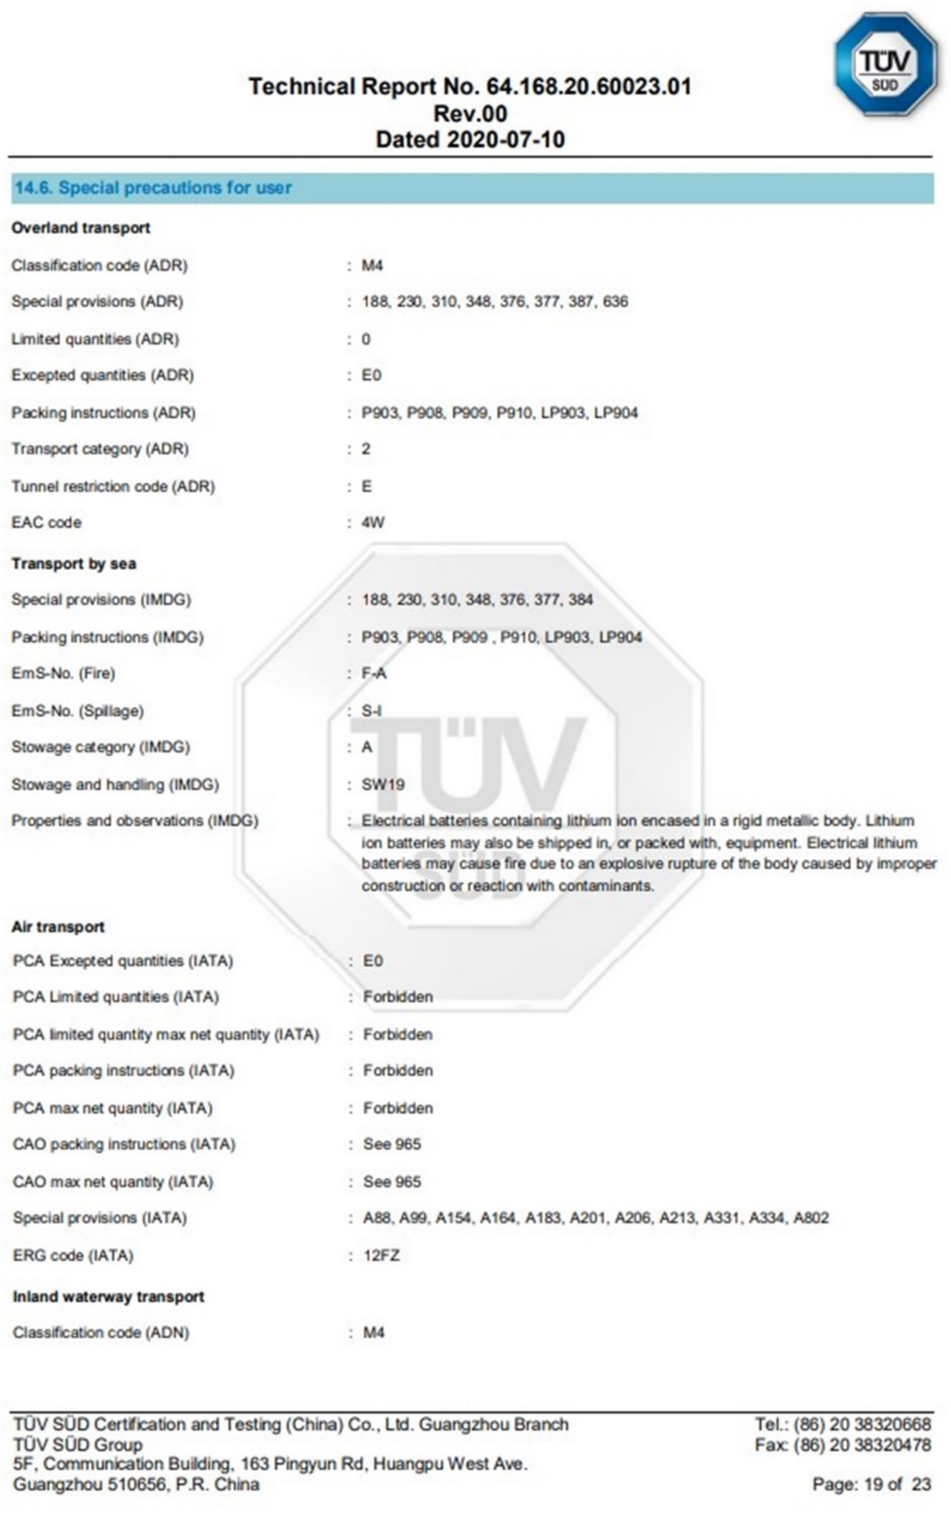
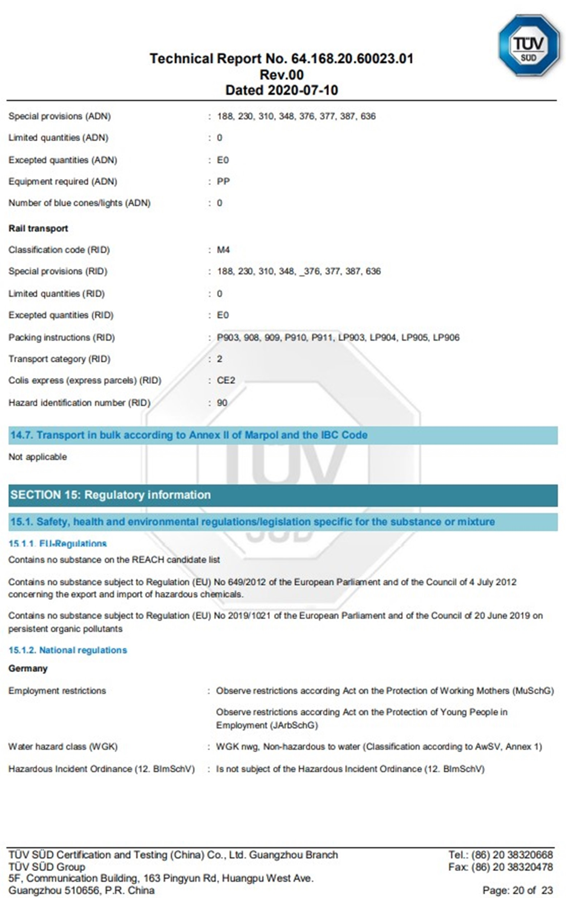
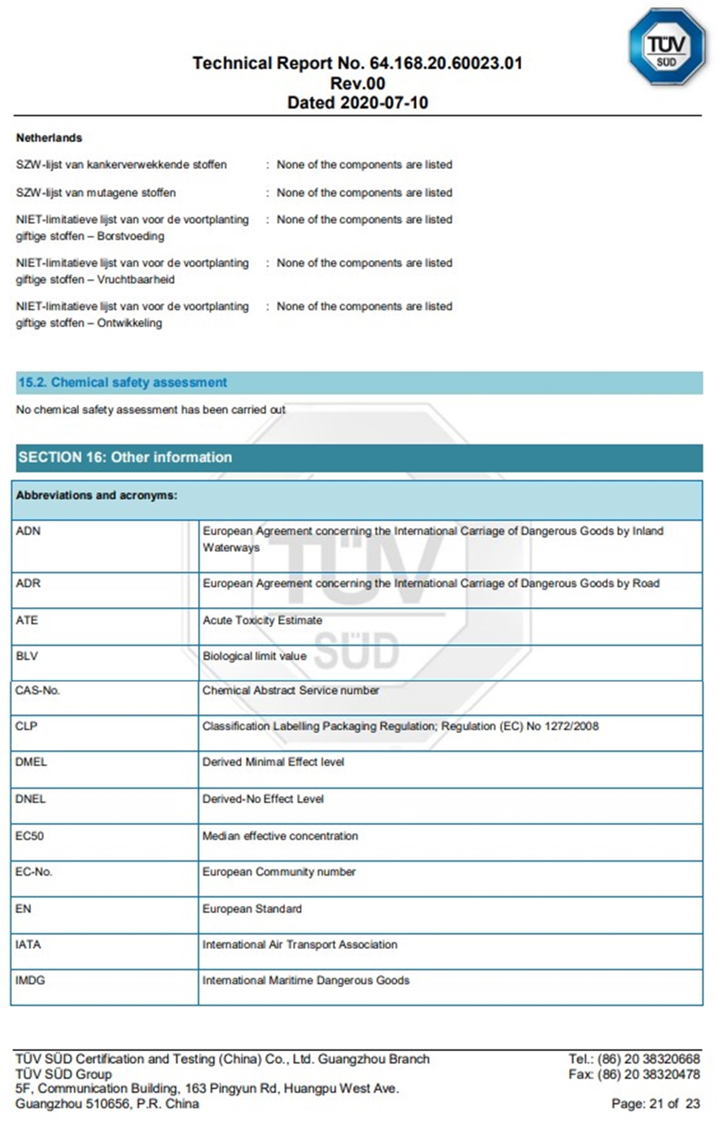
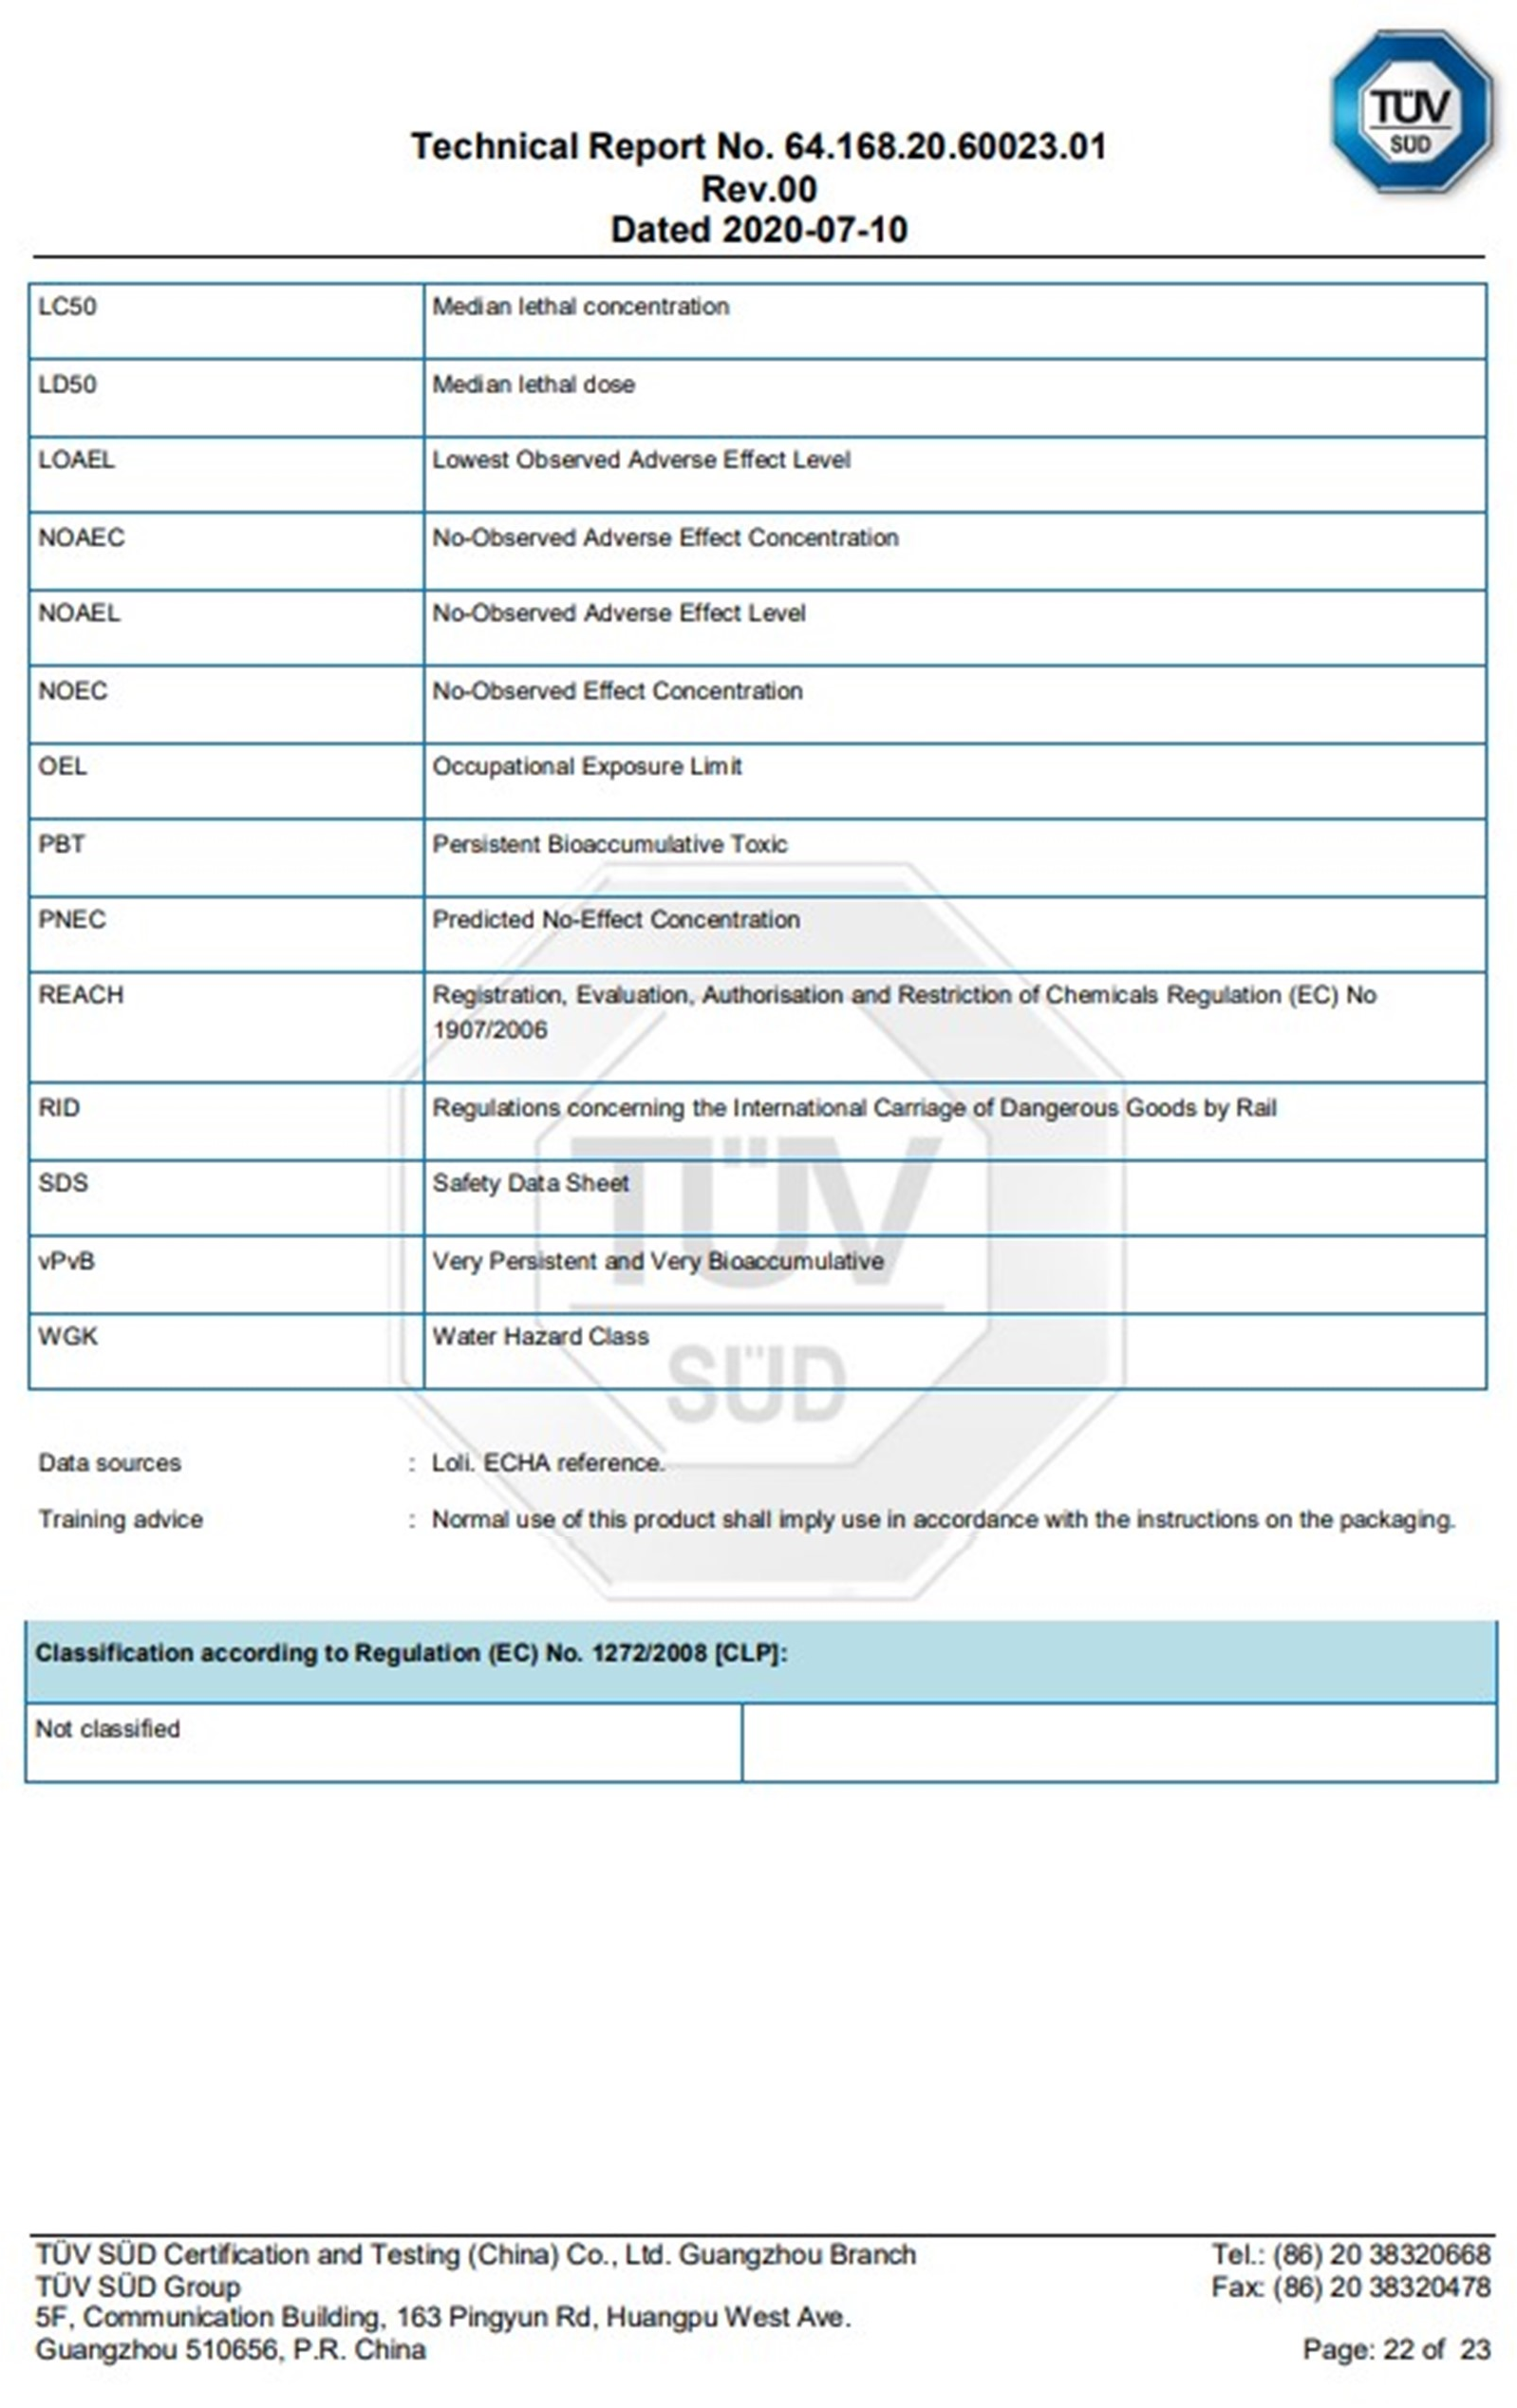
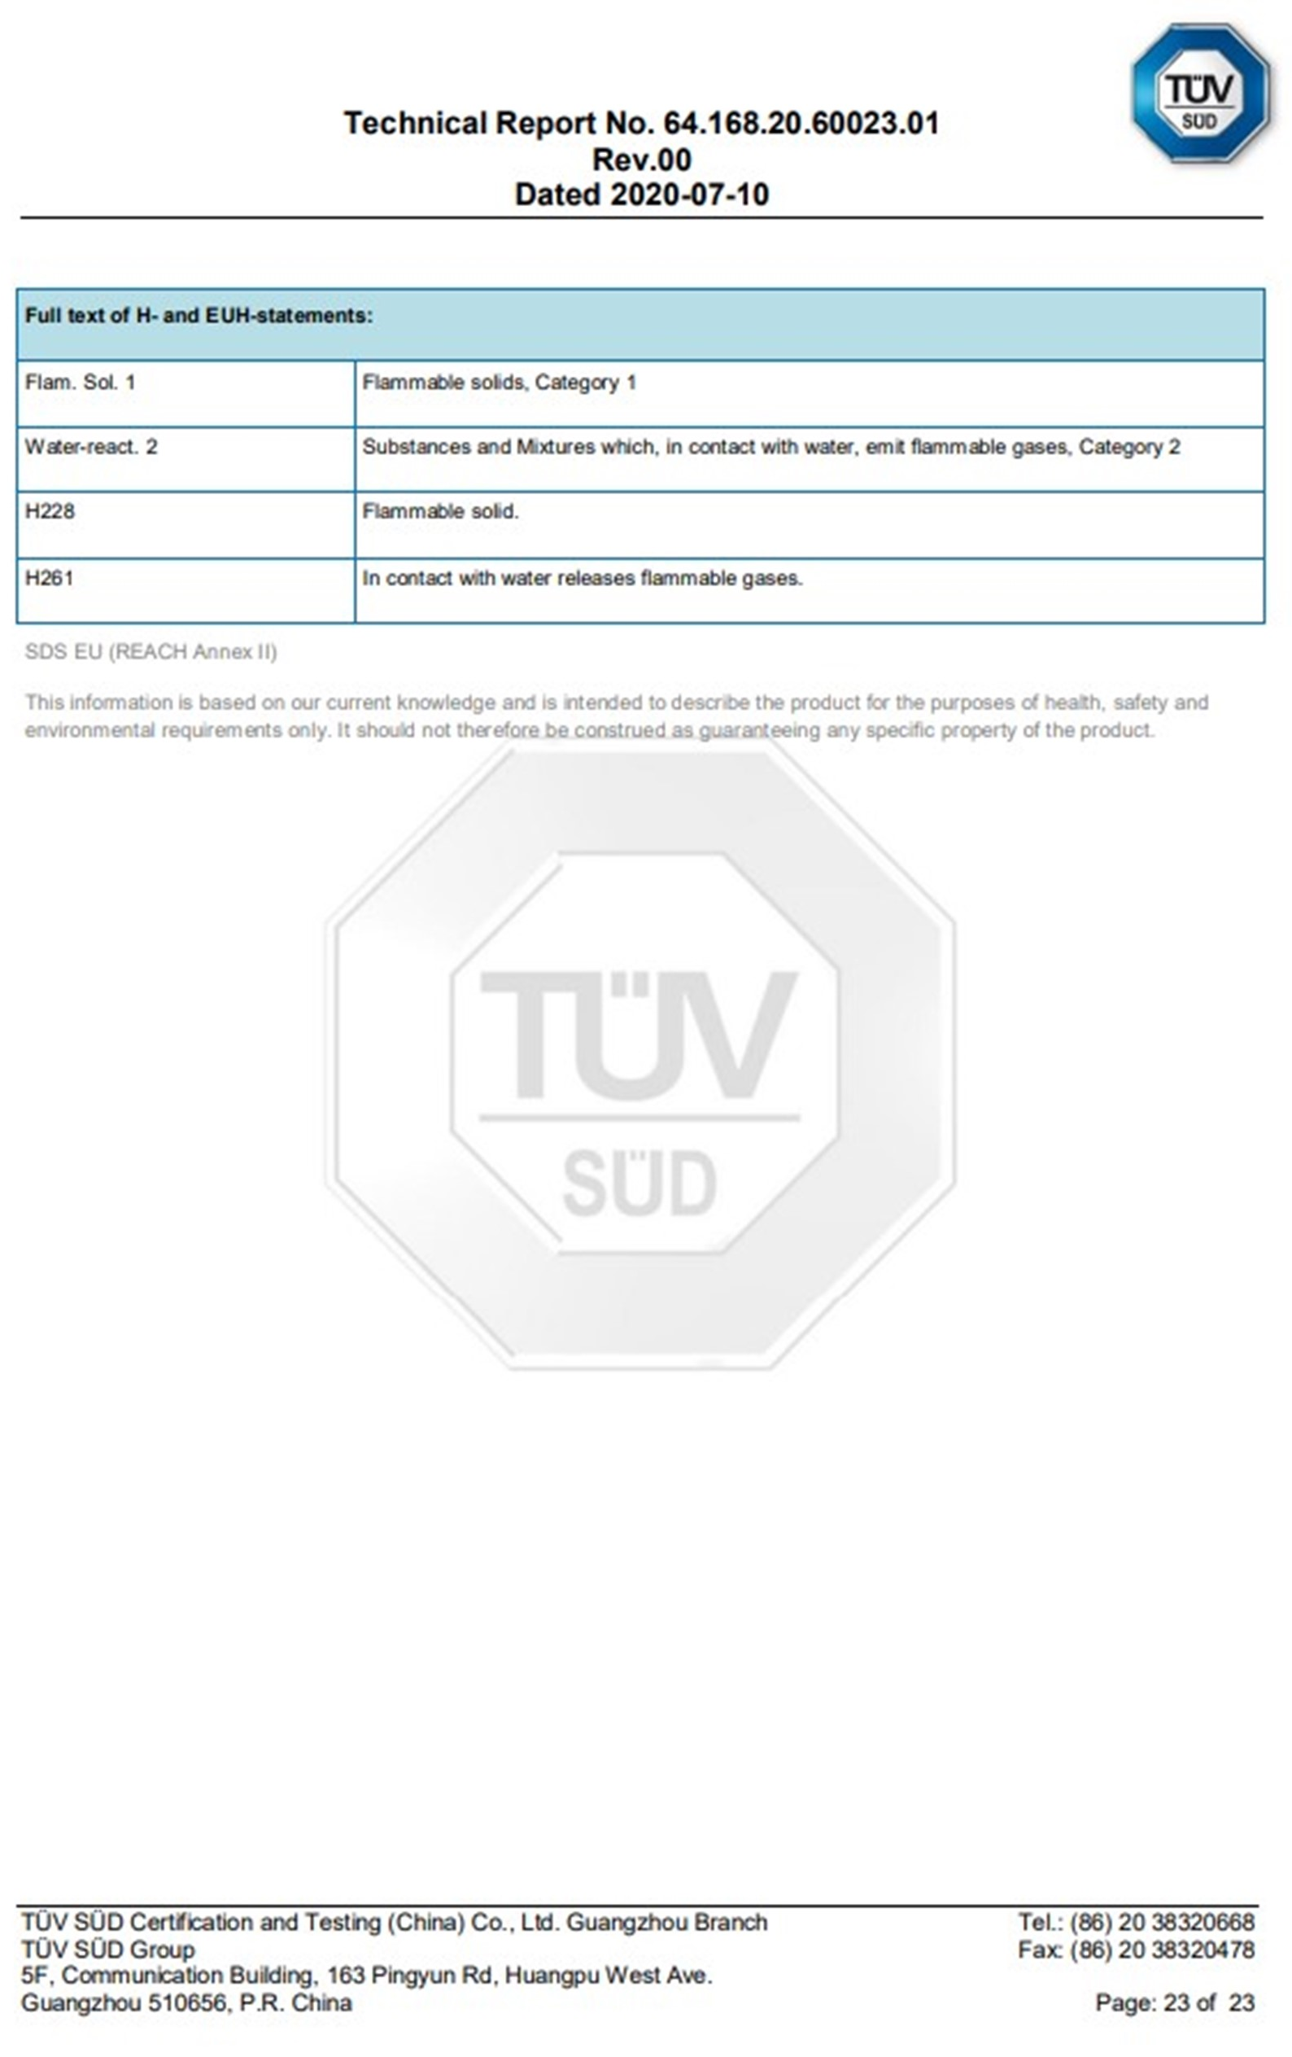
Blank Page
llll✂llllllllllllllllllllllllllllllllllllllllllllllllll✂lllllll |  | Shire Electric Inboard Registration Form
__________________________________________________________________________________

Owner Name:  Address:  Tel:  Email: | Dealer Name:  Address:  Tel:  Email:
Product Model: | Serial Number:
Rental Use: Yes/No | Location:
Date of Delivery:
Owner signature: | Dealer signature:
Please return this form by post to:

Special Products Division Warranty
E. P. Barrus Ltd
Glen Way,
Launton Road,
Bicester,
Oxfordshire,
OX26 4UR

OR by email to: Richard.Cooke@barrus.co.uk
Please keep a copy of the form for your own records.

